**Table Of Contents**

**Network Diagram** 2

**Networking & IP Information** 2

**IP Address Chart** 3

**ADDS Diagram** 3

**Creating & Configuring pfSense** 3

**Creating & Configuring DC1** 13

**Installing ADDS** 16

**Promoting The Core Server (DC1)** 16

**Host Configuration** 16

**Installing & Configuring Linux DHCP** 29

**Creating An Active Directory OU Structure** 37

**SAN Installation & Configuration** 38

**Creating & Configuring HV1 & HV2** 46

**Failover Cluster Configuration** 61

**Live Migration** 68

**Creating & Configuring DC2** 73

**Creating & Configuring FS1** 79

**Creating & Configuring FS2** 81

**Making Mapped Drive & Folder Redirection** 84

**Reflective Writing** 91

# **Network Diagram**

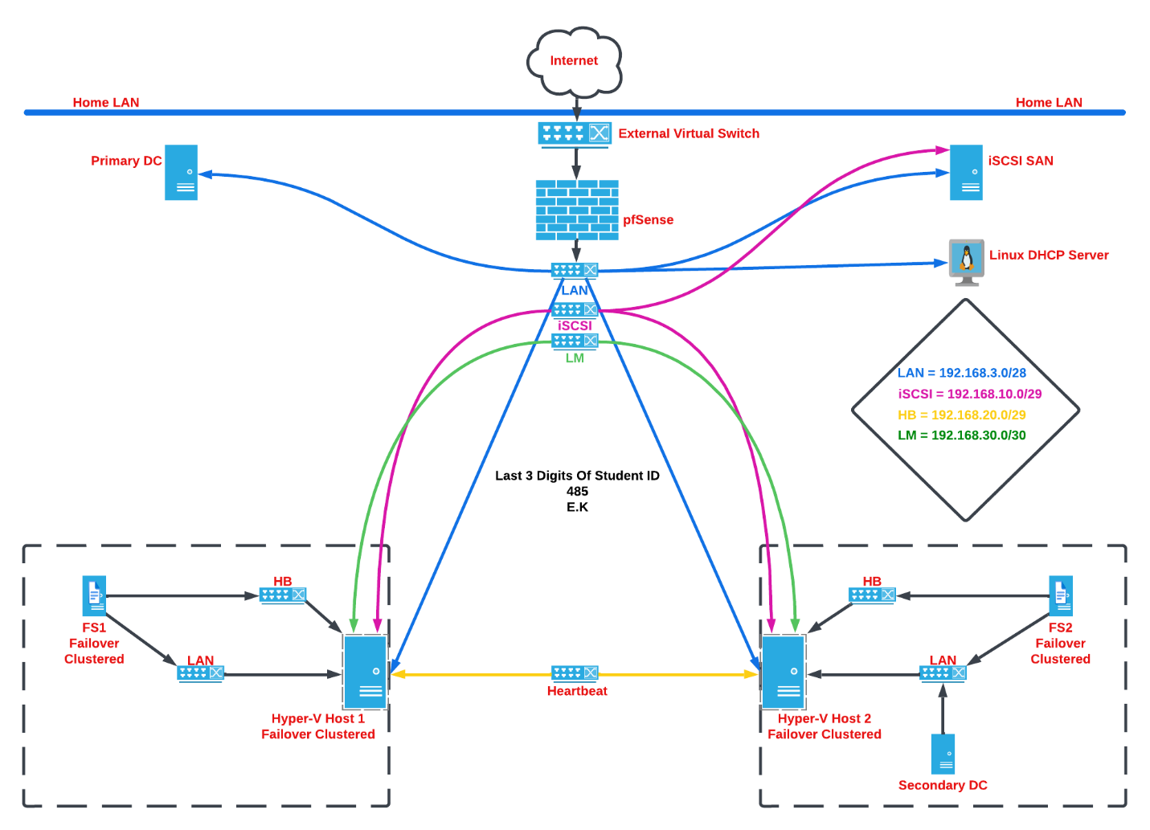

# **Networking & IP Information**

|  |  |  |  |  |  |
| --- | --- | --- | --- | --- | --- |
| **Name** | **Network** | **Purpose** | **Subnet** | **Host IP Range** | **Switch Type** |
| **WAN** | **10.0.0.0/24** | **Home Network** | **------------------------** | **------------------------------------** | **External** |
| **LAN** | **192.168.3.0/28** | **LAN** | **255.255.255.240** | **192.168.3.1-192.168.3.14** | **Internal** |
| **iSCSI** | **192.168.10.0/29** | **iSCSI SAN** | **255.255.255.248** | **192.168.10.1-192.168.10.6** | **Private** |
| **HB** | **192.168.20.0/29** | **Heartbeat** | **255.255.255.248** | **192.168.20.1-192.168.20.6** | **Private** |
| **LM** | **192.168.30.0/30** | **Live Migration** | **255.255.255.252** | **192.168.30.1-192.168.30.2** | **Private** |

# 

# **IP Address Chart**

|  |  |  |  |  |  |
| --- | --- | --- | --- | --- | --- |
| **Devices** | **LAN** | **WAN** | **iSCSI** | **HB** | **LM** |
| **Host** | **192.168.3.13** | **10.0.0.11** |  |  |  |
| **pfSense** | **192.168.3.14** | **10.0.0.254** |  |  |  |
| **DC1** | **192.168.3.1** |  |  |  |  |
| **DC2** | **192.168.3.2** |  |  |  |  |
| **Linux DHCP** | **192.168.3.3** |  |  |  |  |
| **SAN** | **192.168.3.4** |  | **192.168.10.3** |  |  |
| **HV1** | **192.168.3.5** |  | **192.168.10.1** | **192.168.20.1** | **192.168.30.1** |
| **HV2** | **192.168.3.6** |  | **192.168.10.2** | **192.168.20.2** | **192.168.30.2** |
| **HV-Cluster** | **192.168.3.7** |  |  |  |  |
| **FS1** | **192.168.3.8** |  |  | **192.168.20.3** |  |
| **FS2** | **192.168.3.9** |  |  | **192.168.20.4** |  |
| **FS-Cluster** | **192.168.3.10** |  |  |  |  |
| **File Server** | **192.168.3.11** |  |  |  |  |

# **ADDS Diagram**

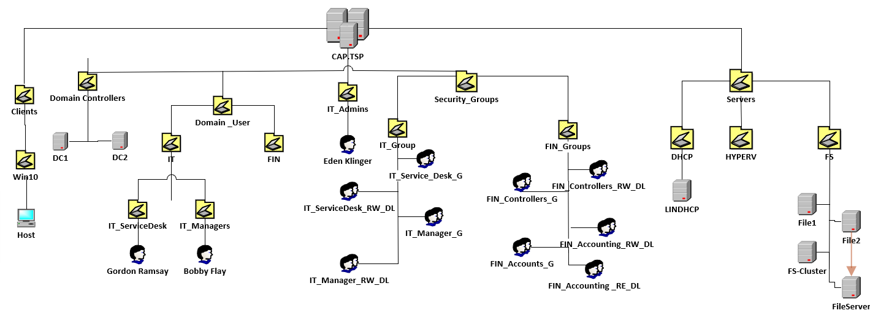

# **Creating & Configuring pfSense**

Head over <https://www.pfsense.org/download/> and download pfSense to create our Firewall with NAT Routing. Select the same options as the image below, proceed to download.

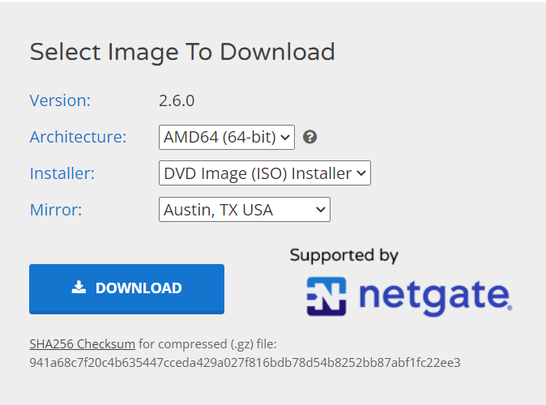

Create your Virtual Machine with the following settings:

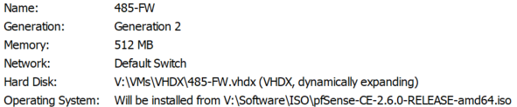

Uncheck “Use Automatic Checkpoints”

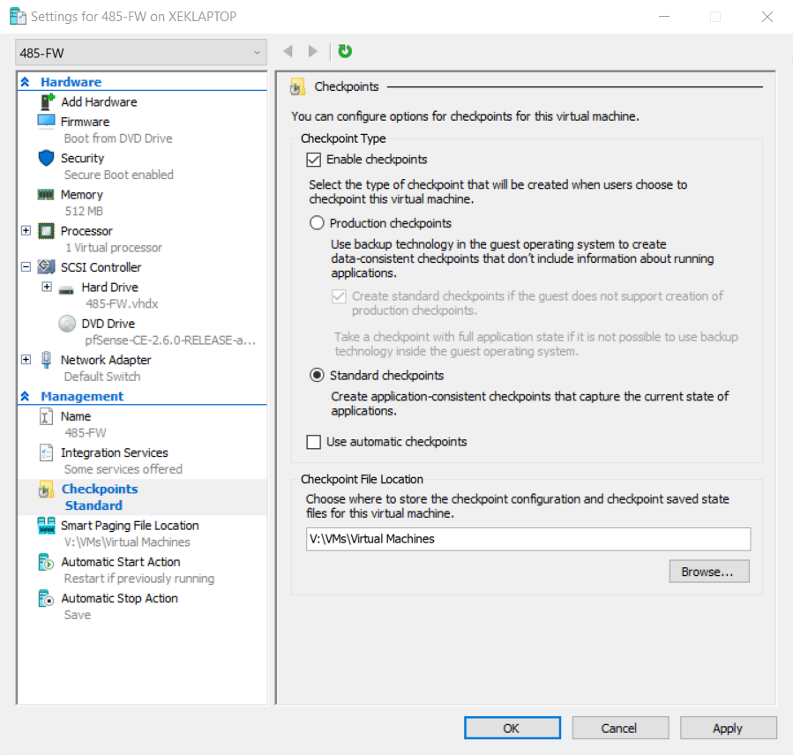

Enable “Guest Services”

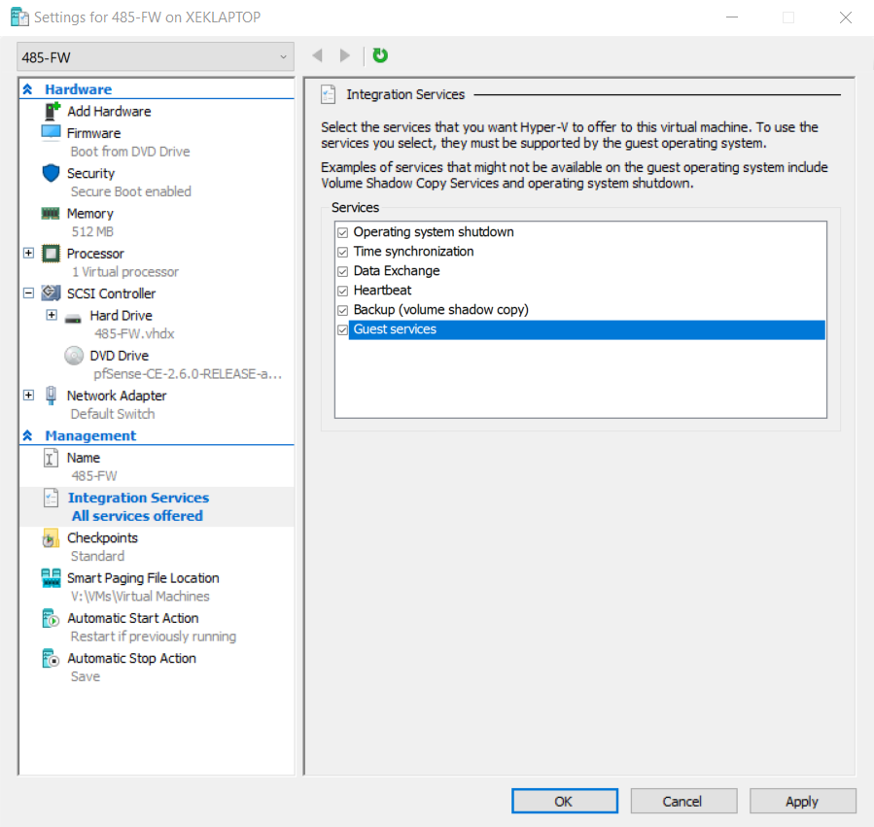

Uncheck “Enable Secure Boot”

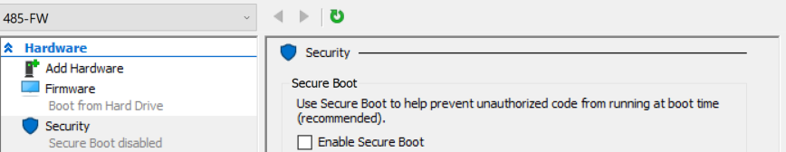

We’re now going to add our second adapter “LAN”

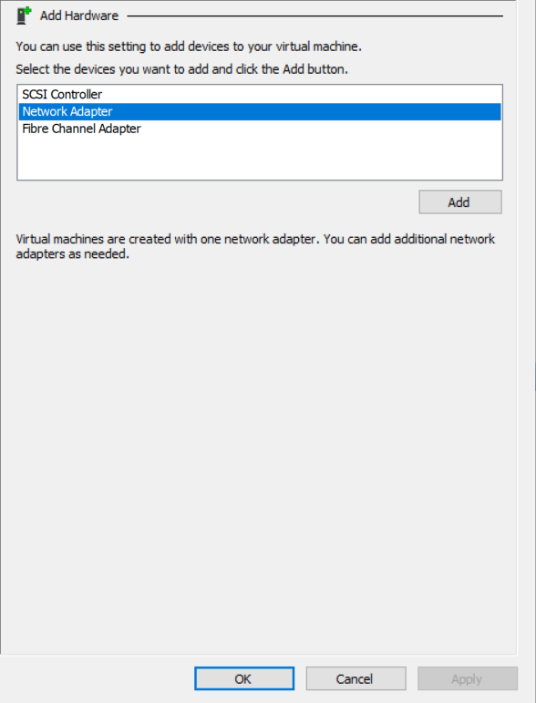

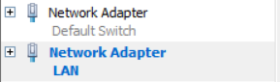

Now proceed to boot pfSense.

After the VM reboot, turn it off and remove the disk to avoid going through the installation process again. Start the VM.

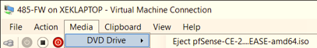

We’re now going to configure pfSense. 

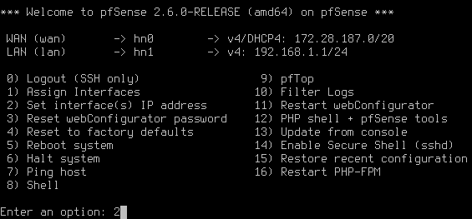



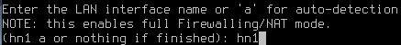

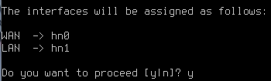

Configure the LAN (hn1)

’

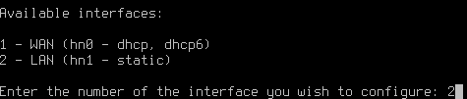’ ’

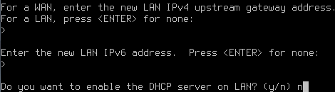

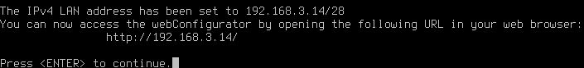

Now head to your host machine’s network adapters and edit your “LAN”.

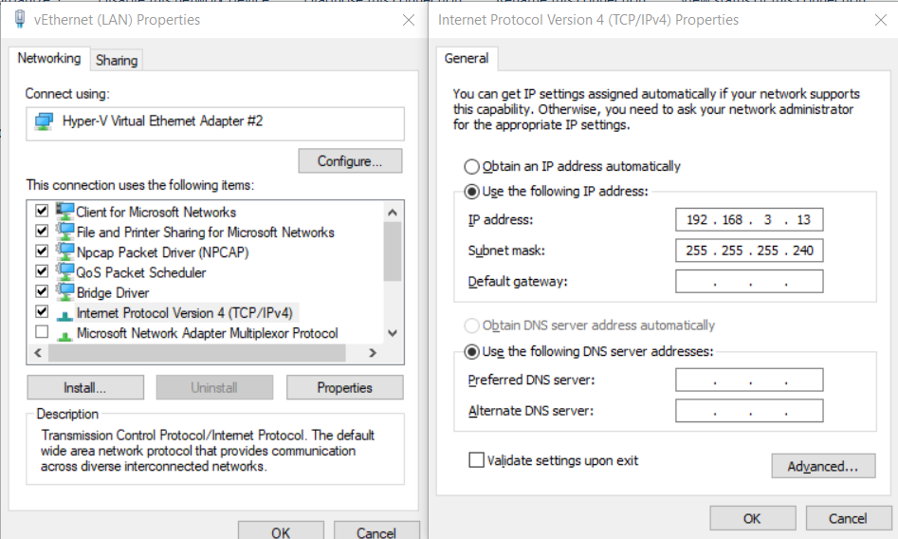

Now head over to pfSense using the LAN you configured (<http://192.168.3.14/>)

Login using the following, Username: admin | Password: pfsense

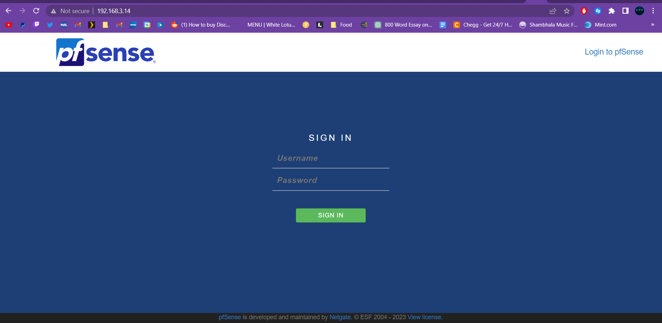

We’re now going to configure our firewall.

I disabled DNS Resolver & Enabled DNS Forwarder

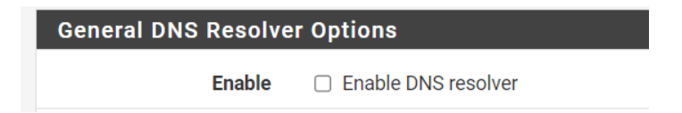

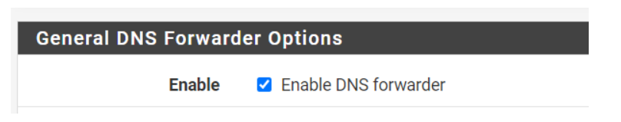

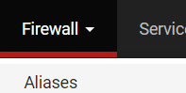





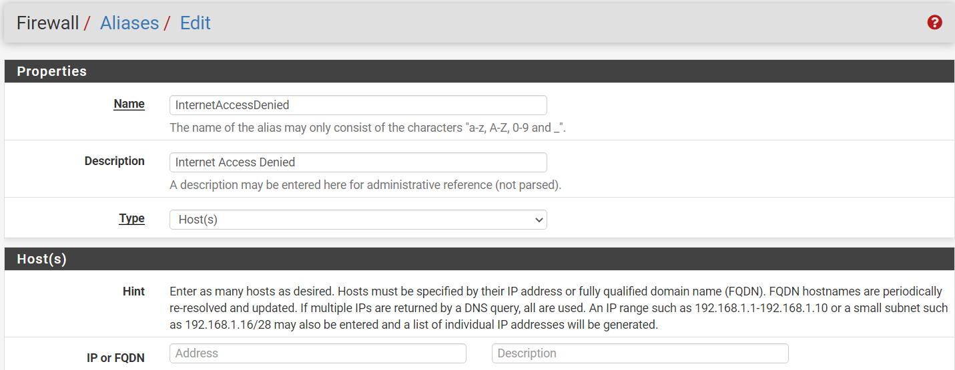

Create an alias, then press save.

Go to Firewall, Rules, LAN then click the add button.

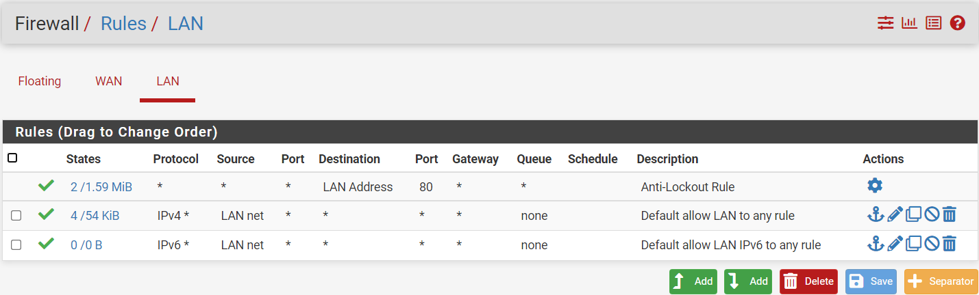

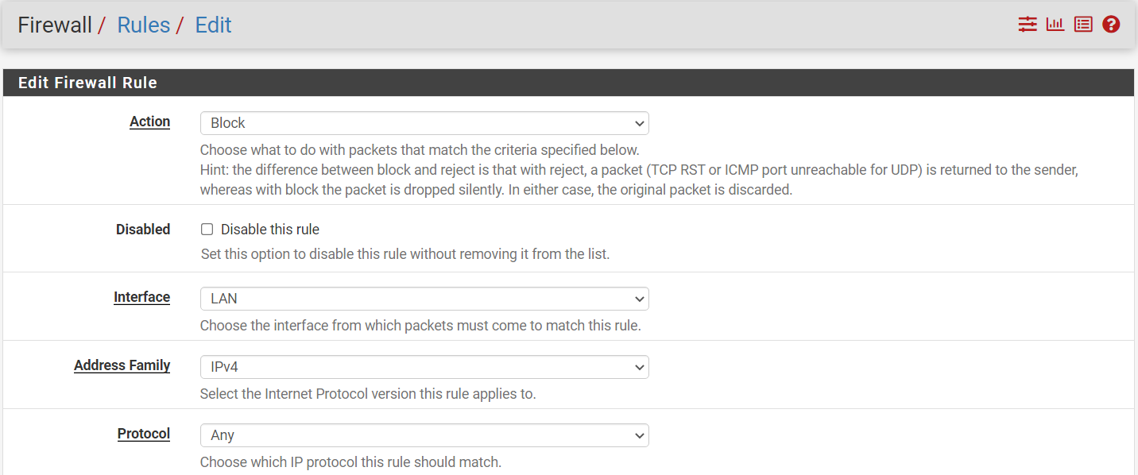



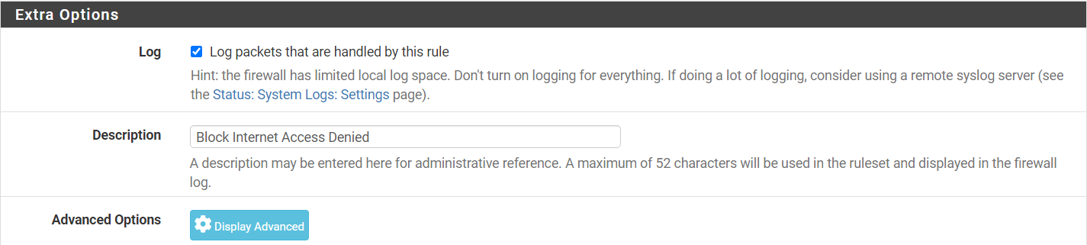



Now we’re going to head back to Firewall/Aliases/Edit.



We’re going to click the little pencil and add the devices we’re going to block.



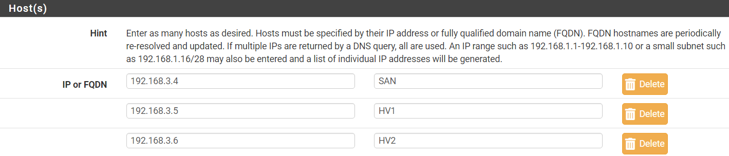

(Disable this for now).

# **Creating & Configuring DC1**

We’re now going to create our DC1, I used a parent disk to speed up the process.

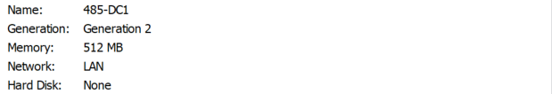







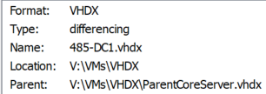

I used the following password:

(Pa$$w0rd)

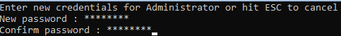

We’re now going to do our post installation setup using the following script.

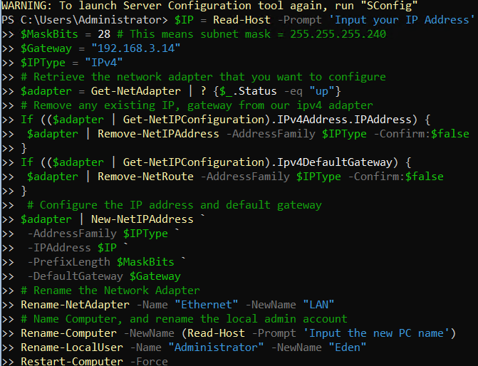

Then input your IP Address “192.168.3.1”.

Then input your PC’s name “485-DC1”.

We’re now going to disable the firewall.



Now we will enable the server’s response to pings.

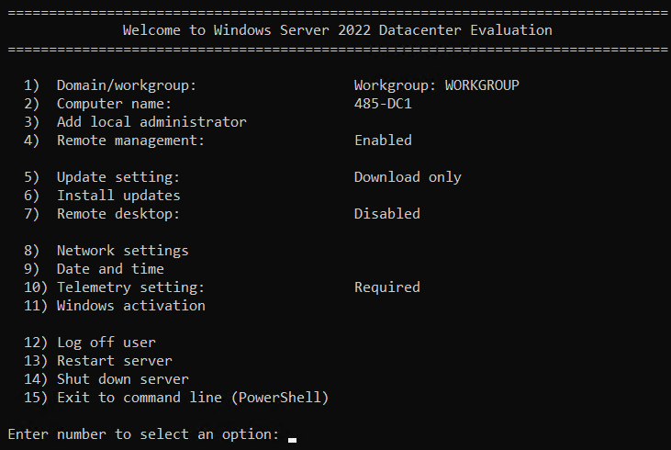



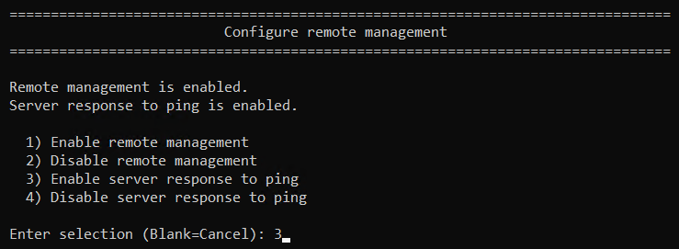

We’re now going to create our ADdb drive to store our SYSVOL and NTFS.

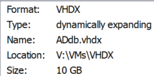

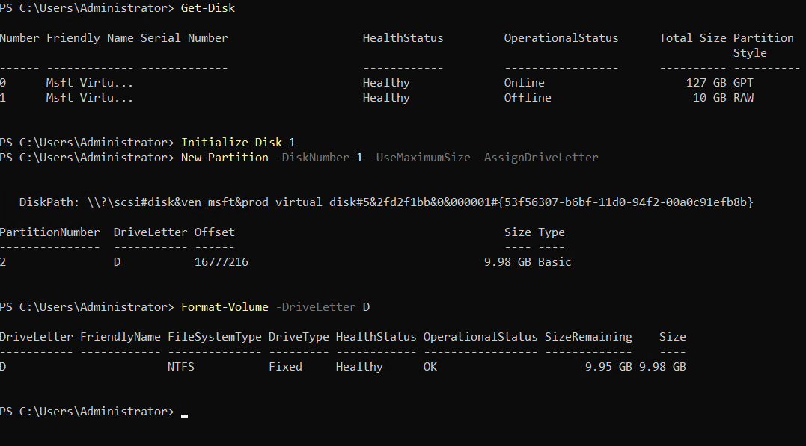

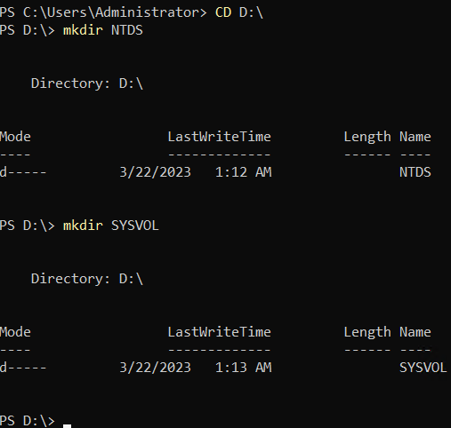

# **Installing ADDS**

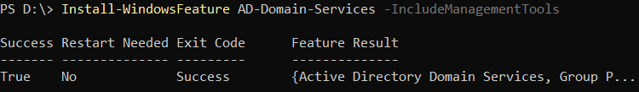

# **Promoting The Core Server (DC1)**

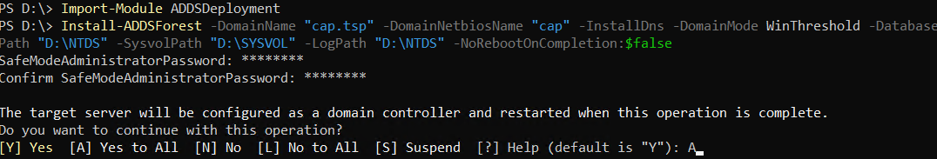

# **Host Configuration**

You’re now going to head to your LAN Adapter on your host machine and add your DC1 as your DNS.

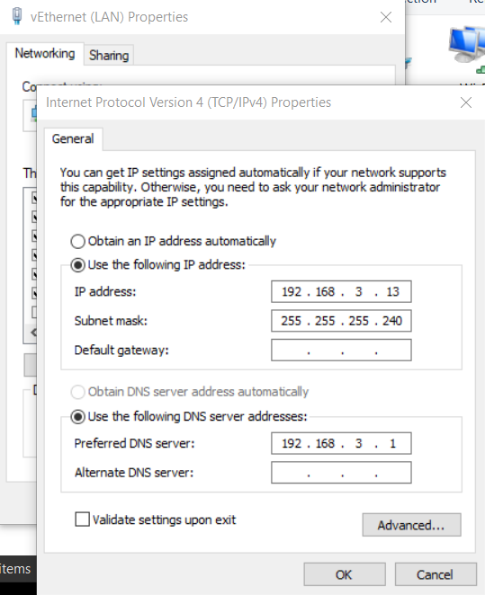

Type “name” in your search bar.





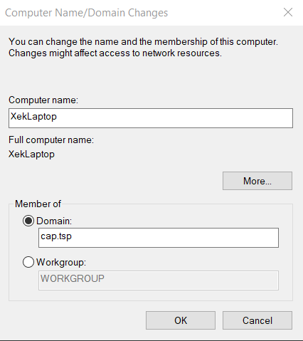

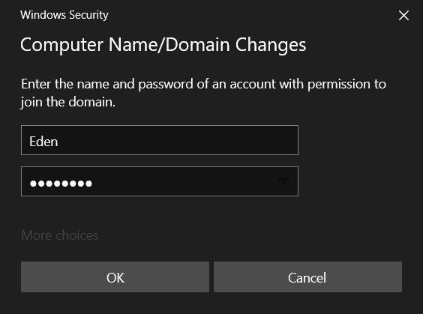

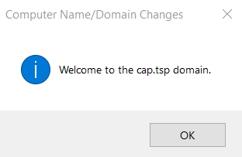

We’re now going to install the following RSAT Tools:

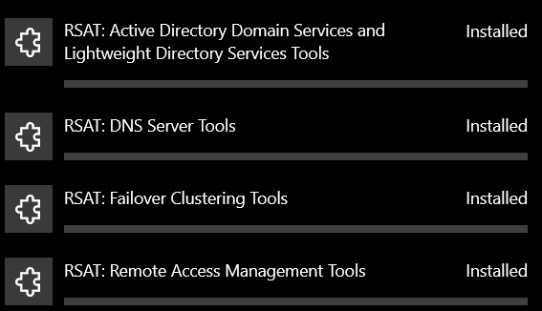







Next, you’re going to add DC1 to Server Manager.

Right click “All Servers” and select “Add Servers”.





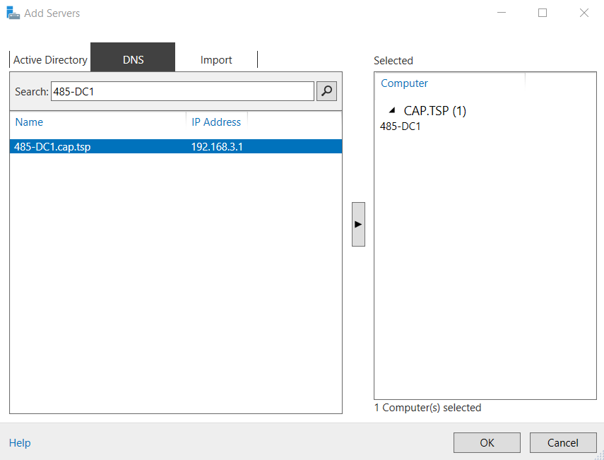





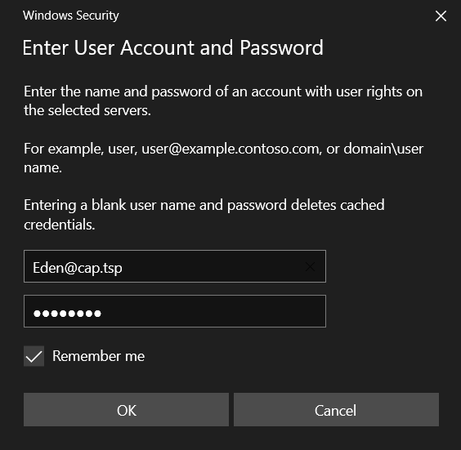



Now we’re going to create a DNS Reverse Lookup Zone

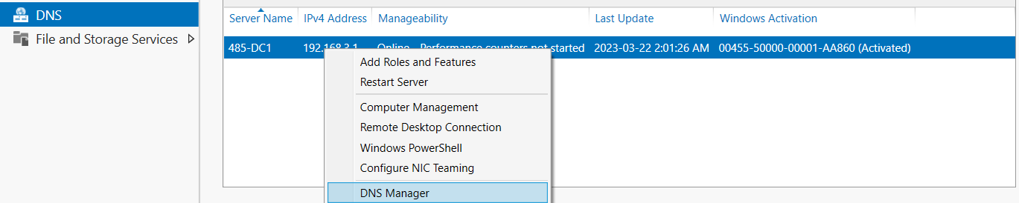

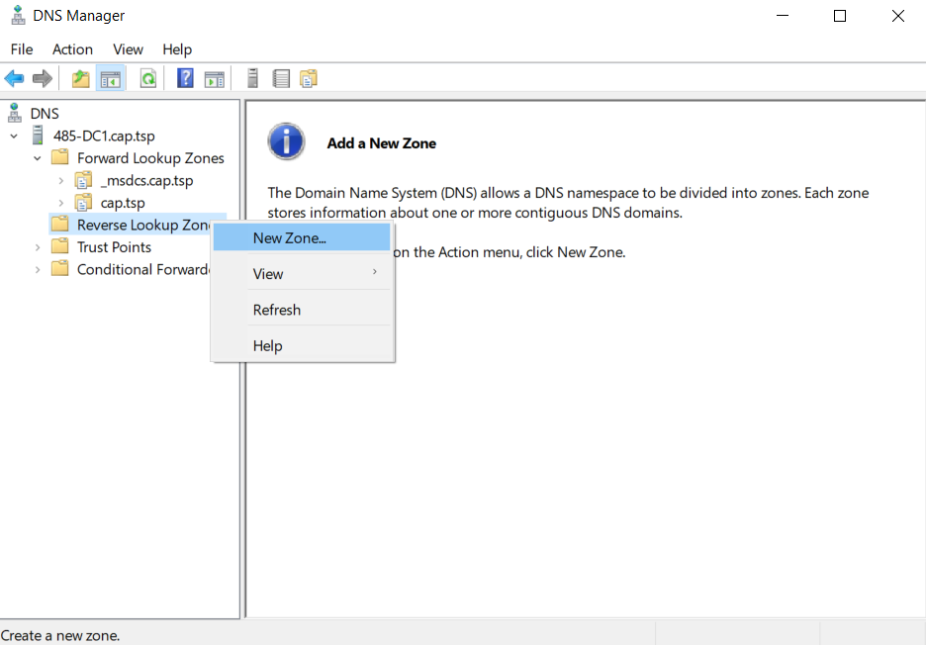

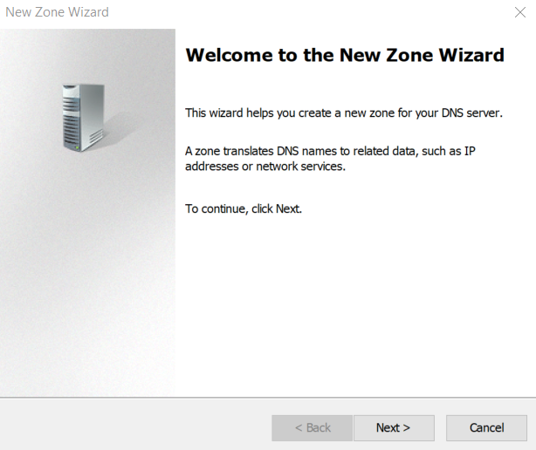

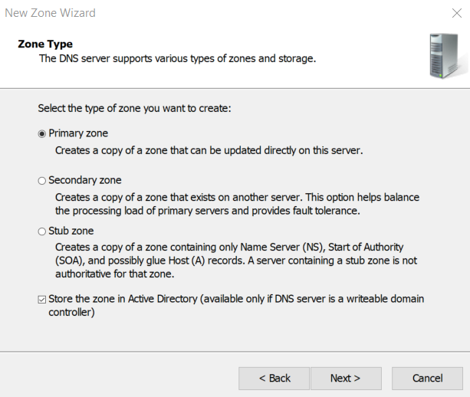

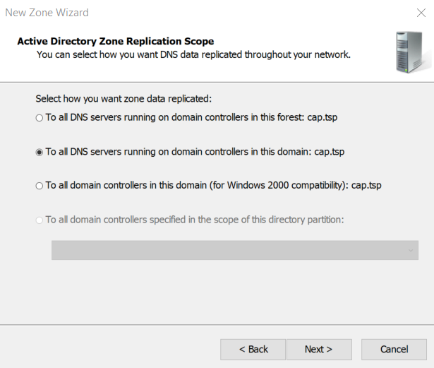

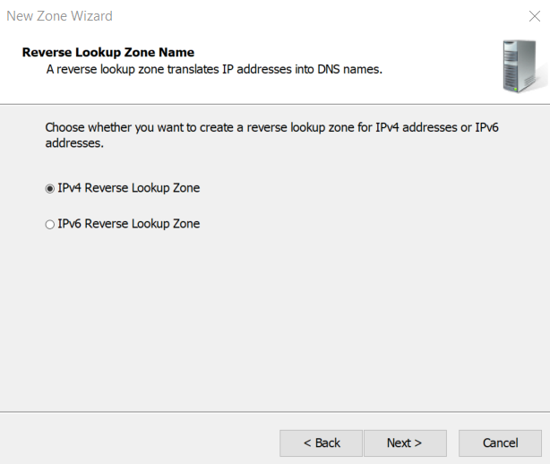

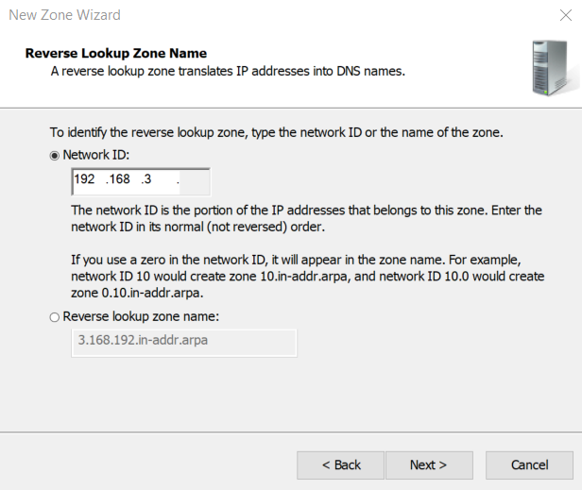

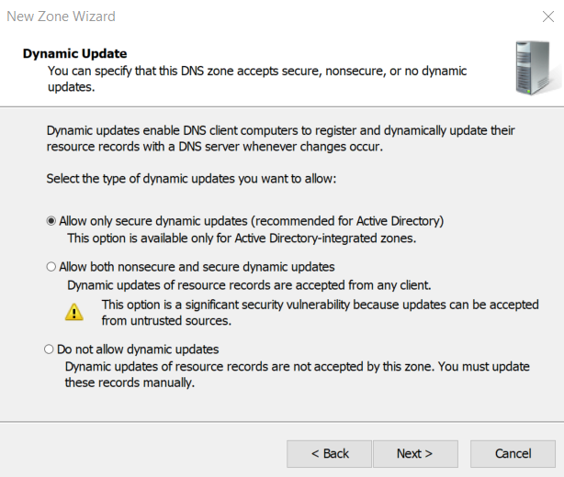

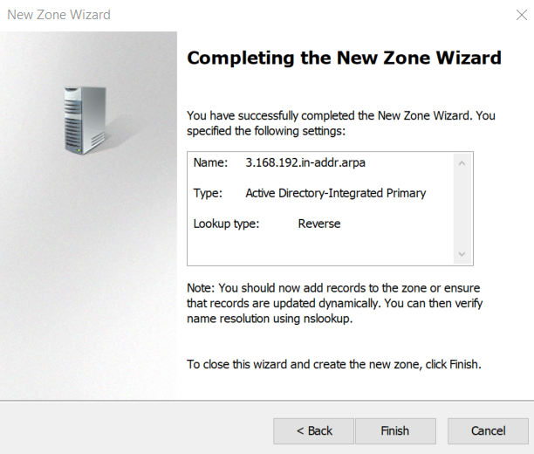

We’re now going to add our pfSense default gateway as our forwarder to reach the internet.

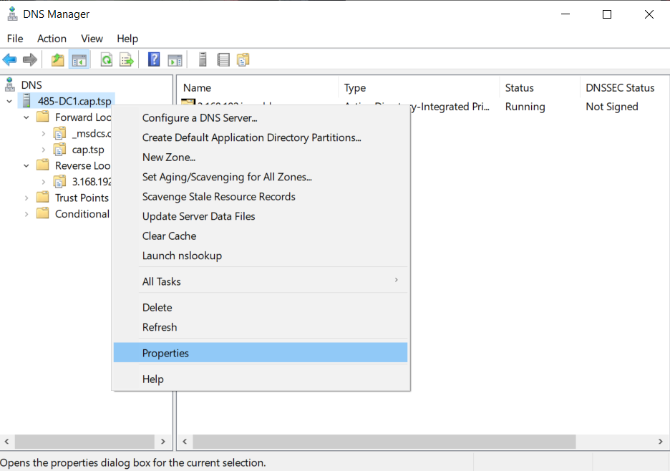

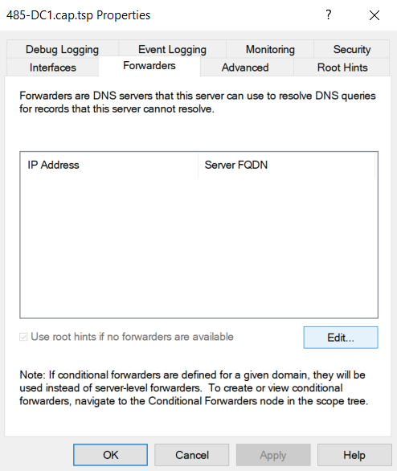



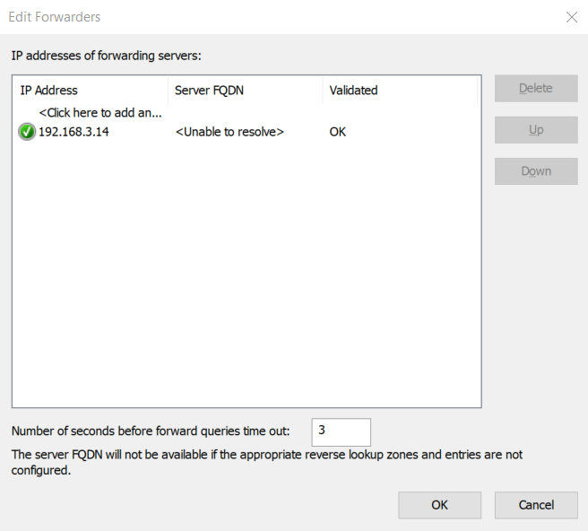

We’re now going to add an “A Record” in DNS for our pfSense.

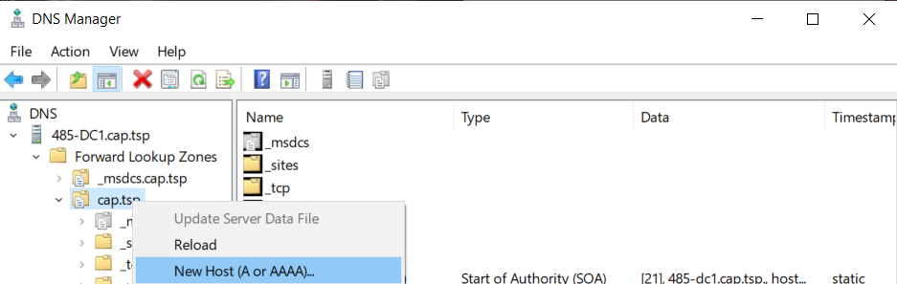

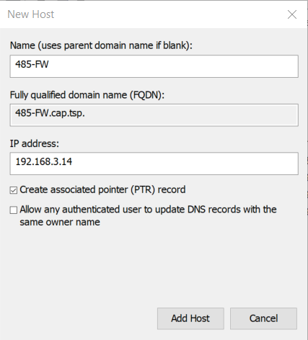

Next we will add a PTR record in our Reverse Lookup Zones for our “485-FW/485-DC1”



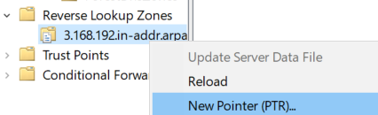

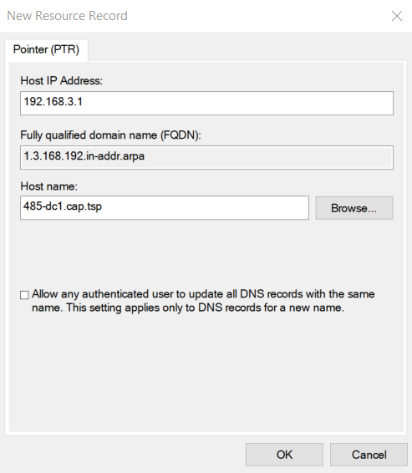



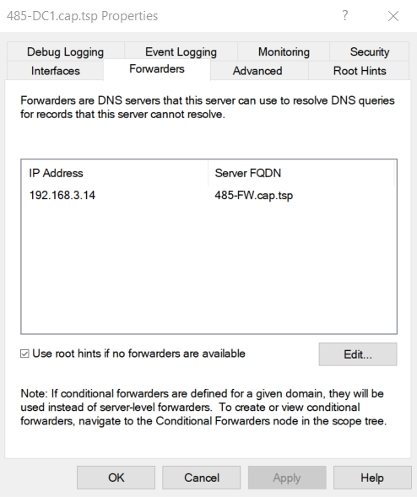

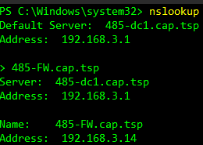

# **Installing & Configuring Linux DHCP**

We’re now going to create a CentOS VM.

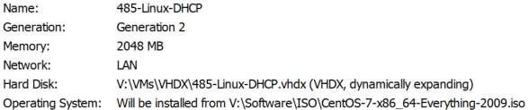

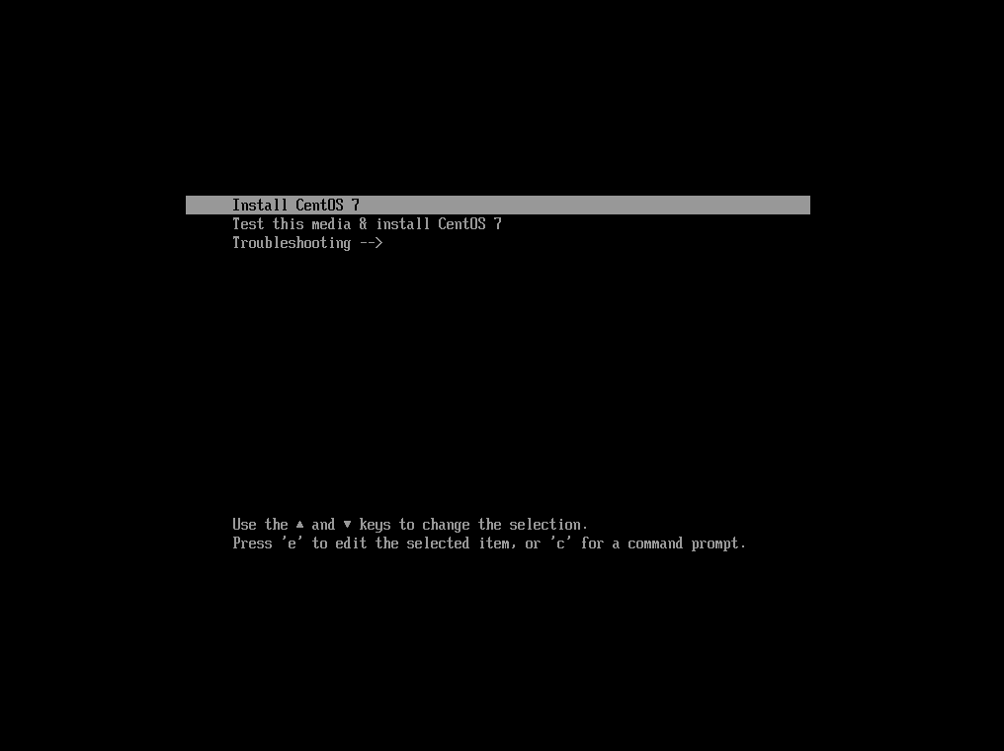

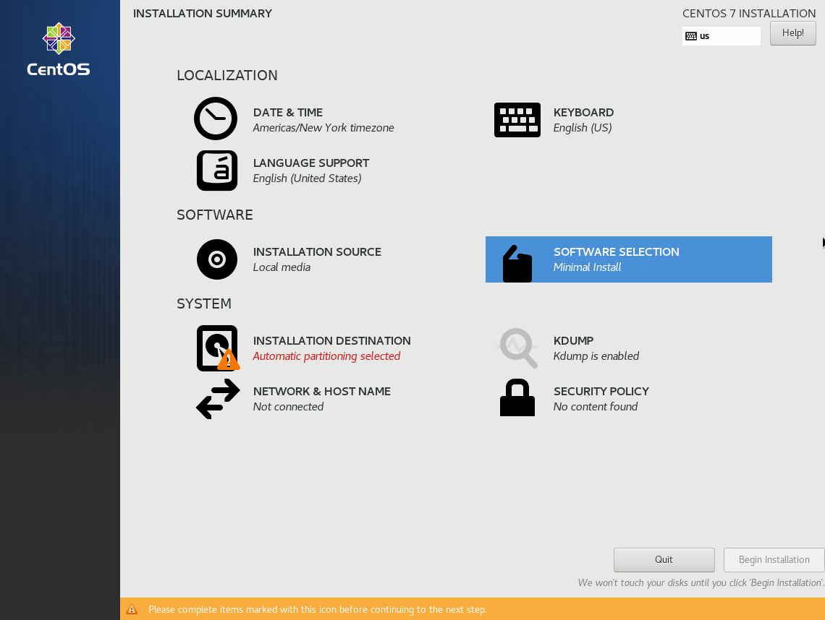

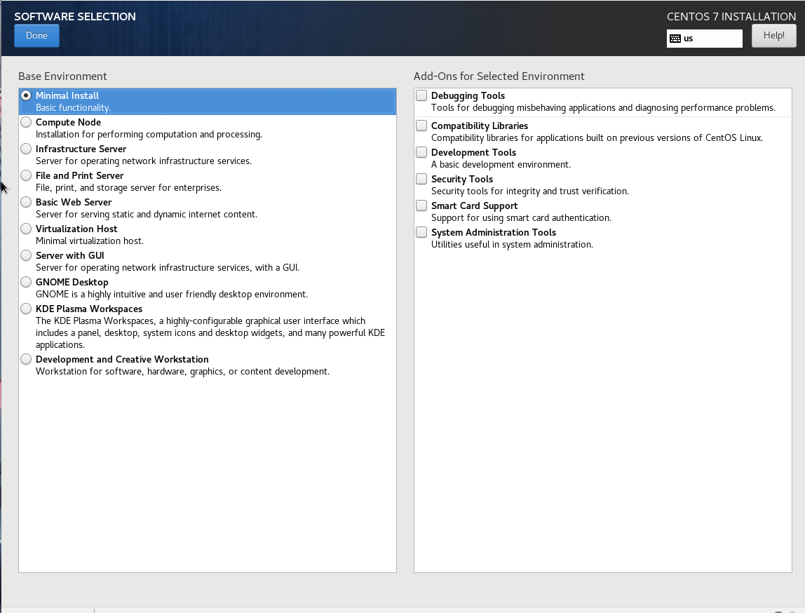

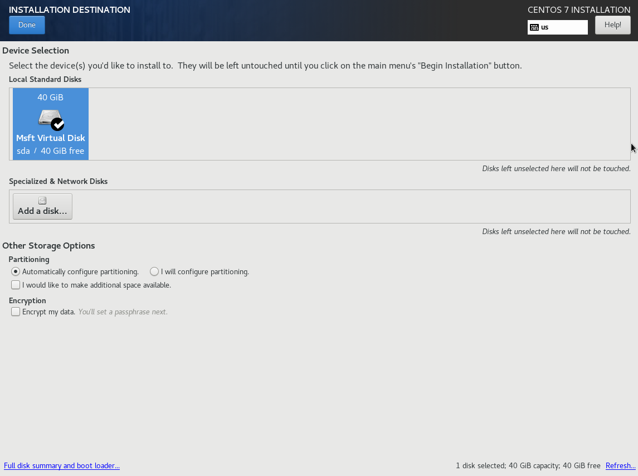

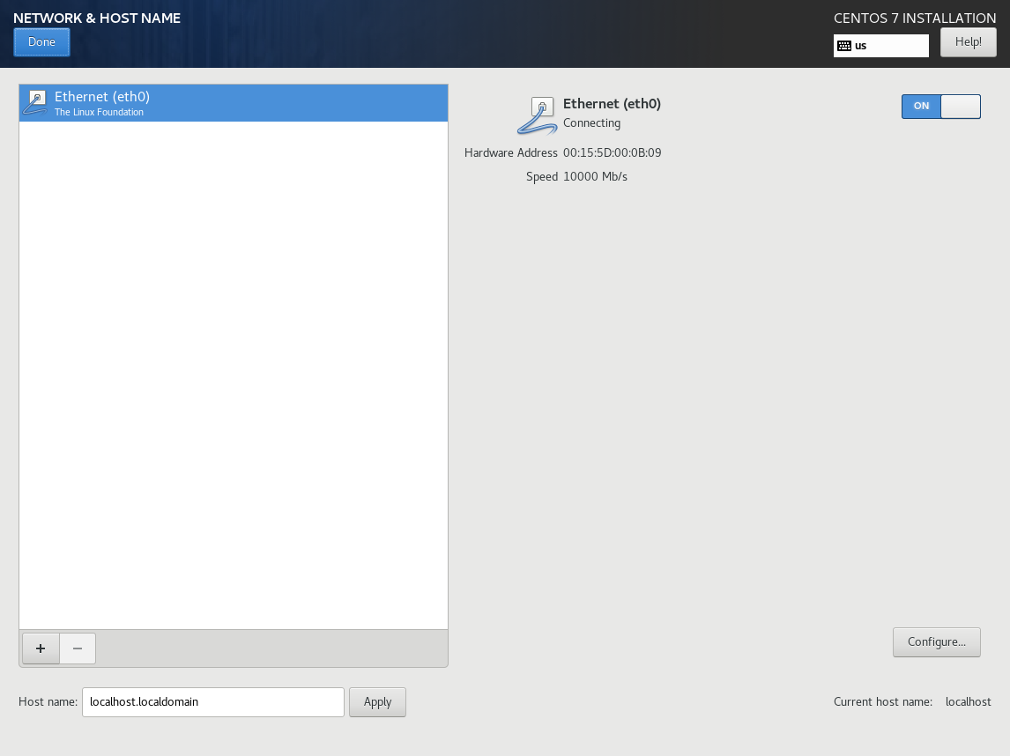

(I forgot to add my hostname)



We’re now going to assign our “485-Linux-DHCP” IP address.





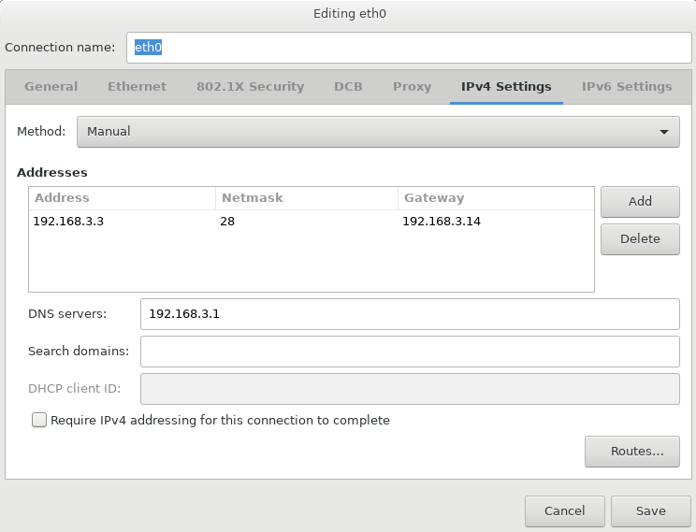



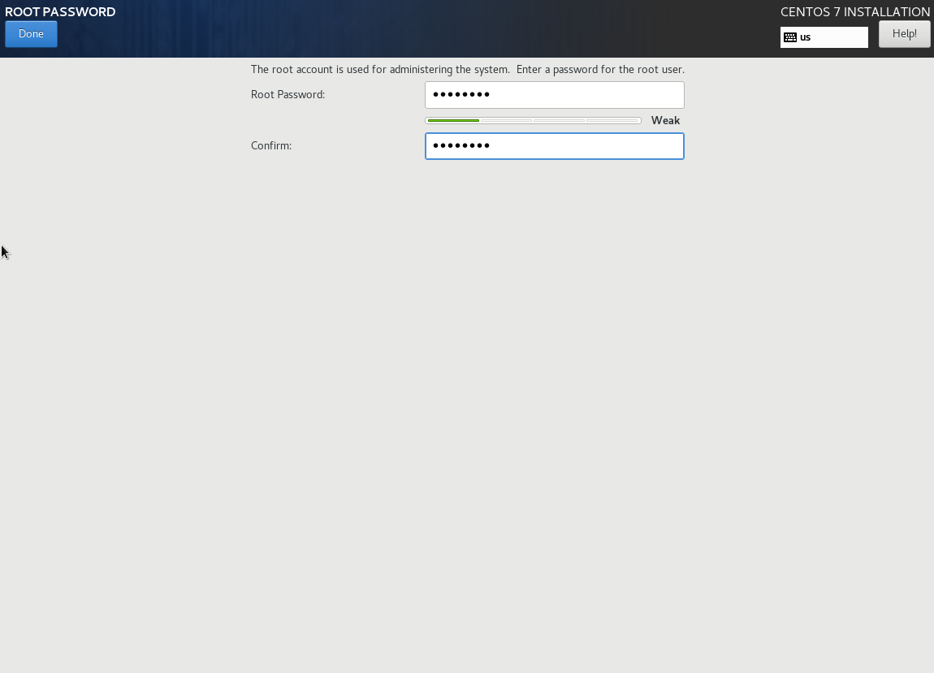

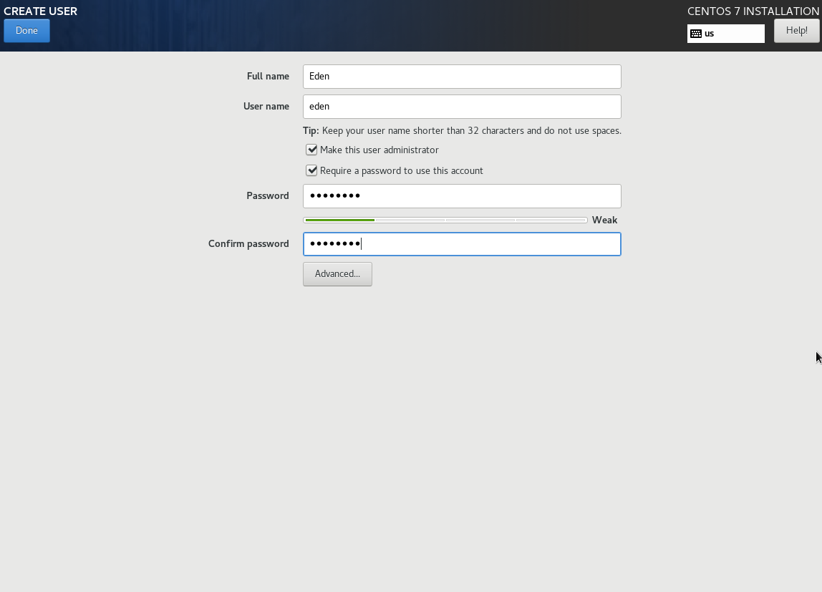

We’re now going to install DHCP in our CLI.



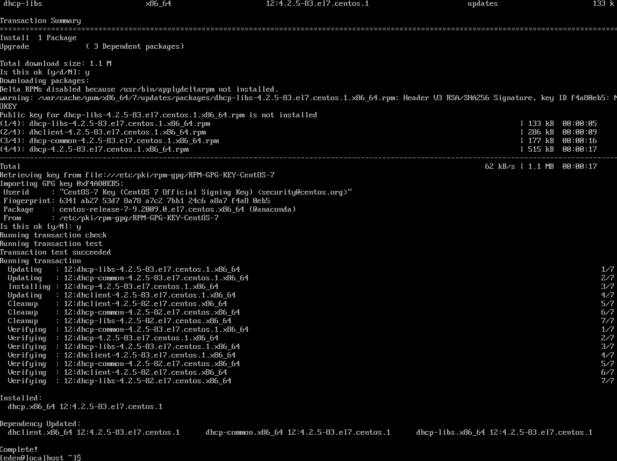





Add the following:

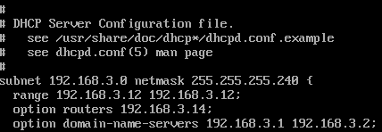





Now we’re going to join the domain.





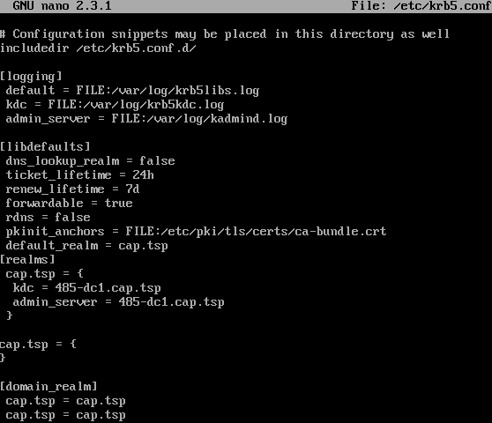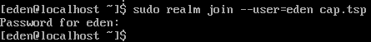

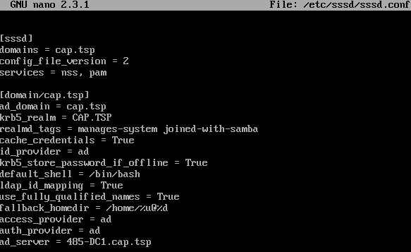

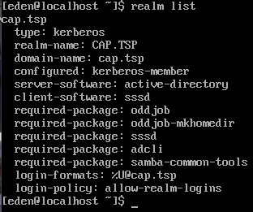

# **Creating An Active Directory OU Structure**

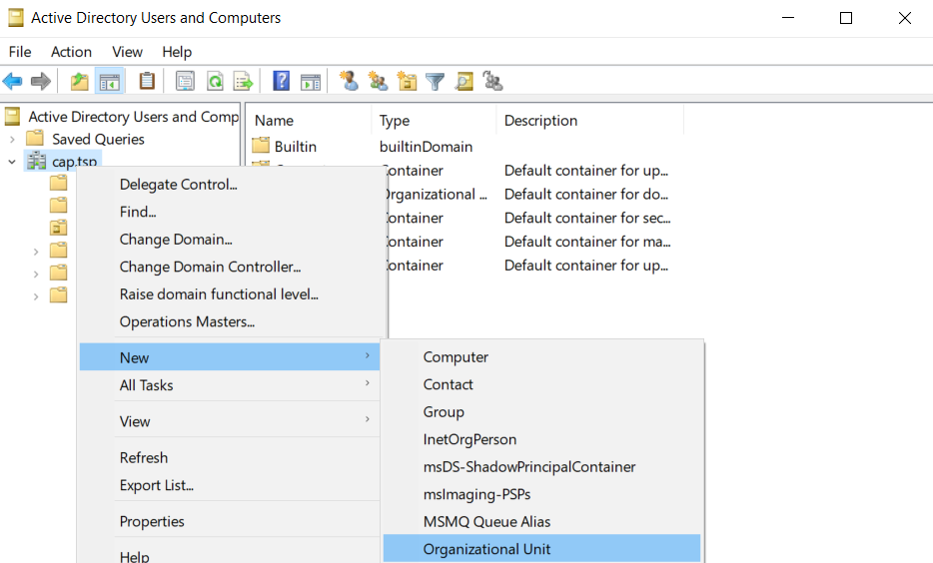

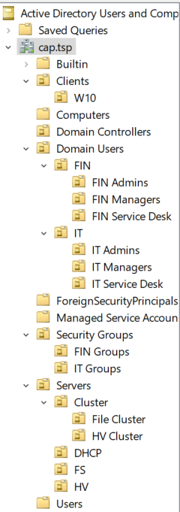

# **San Installation & Configuration**

We’re going to create our SAN VM.

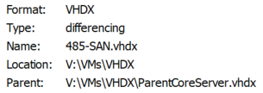

You’re now going to add a second network adapter.

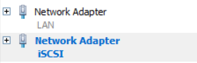

Proceed to boot the VM.

Head to Powershell and run this script:

This is the post installation setup for our SAN.

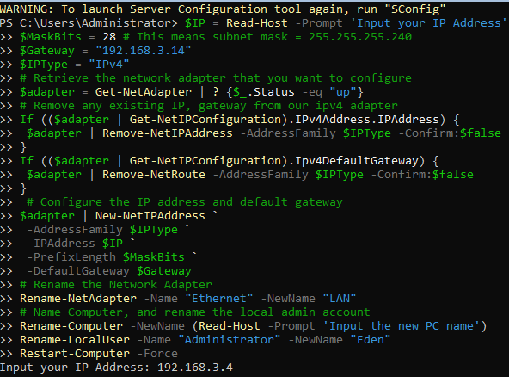



Your SAN will now restart.

We’re now going to change the iSCSI IP Address.

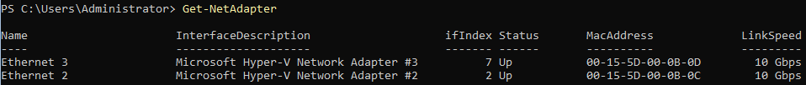

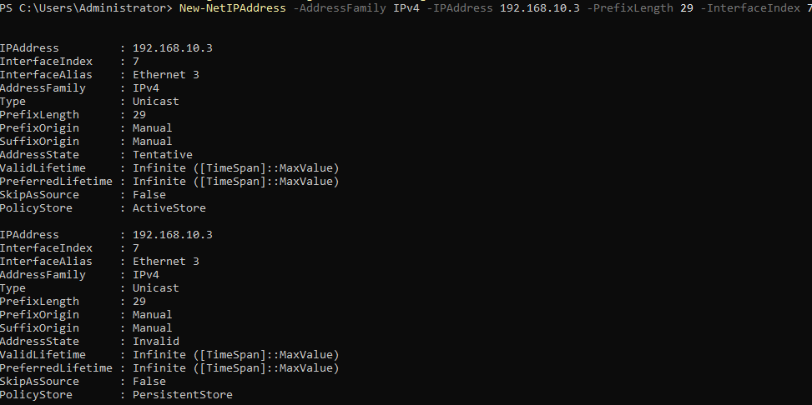

Disable the firewall.



We’re now going to enable “Jumbo Packets”.

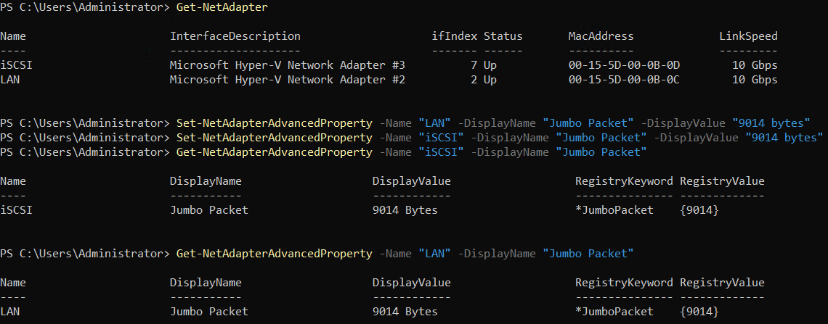

We’re now going to add 6 additional 45GB disks to the SAN.

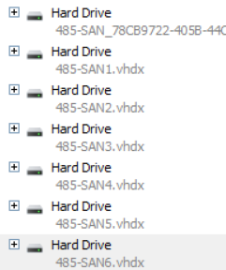

Now we will be establishing trust between our SAN and our Host as it’s not domain joined.

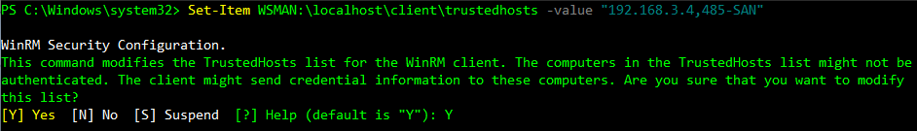

Now we’re going to add our SAN to your Server Manager.

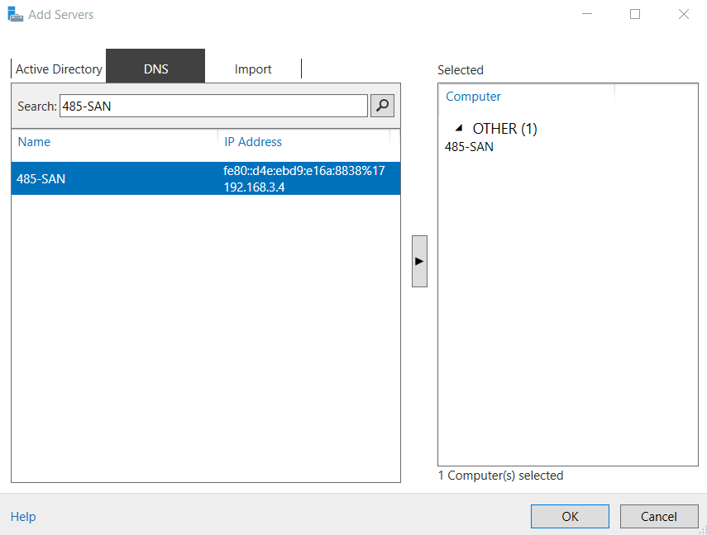

Now we’re going to go to “Manage As” to get rid of the Kerberos error.

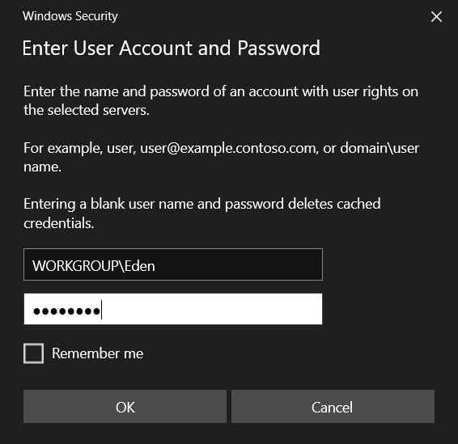

We’re now going to bring all 6 of our newly created disks online using the following command:

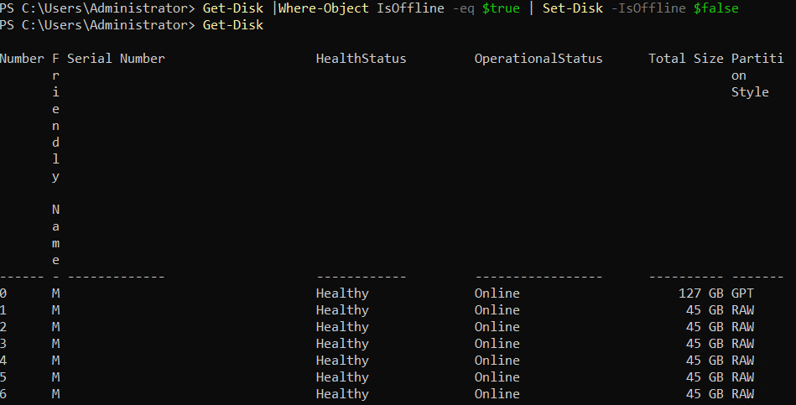

We’re now going to create a Storage Pool.



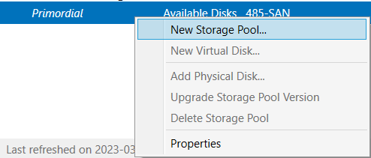

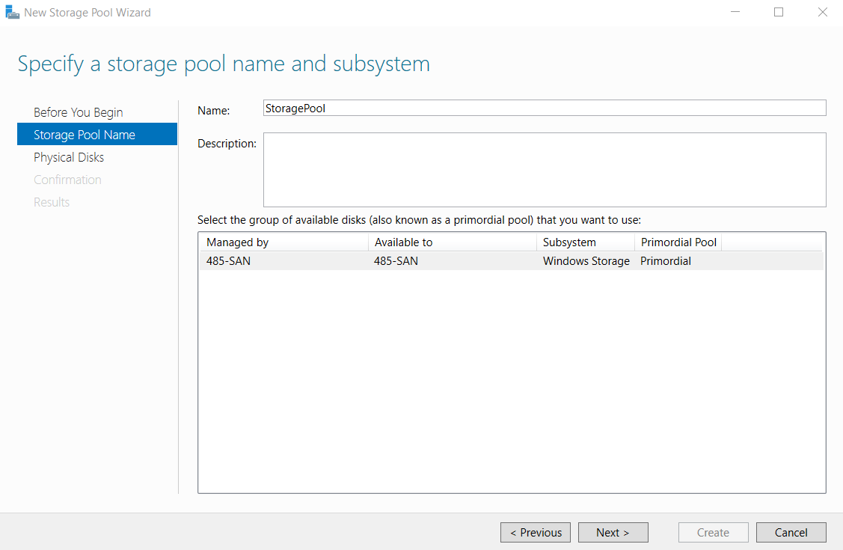

Select all 6 of the disks we’ve added.

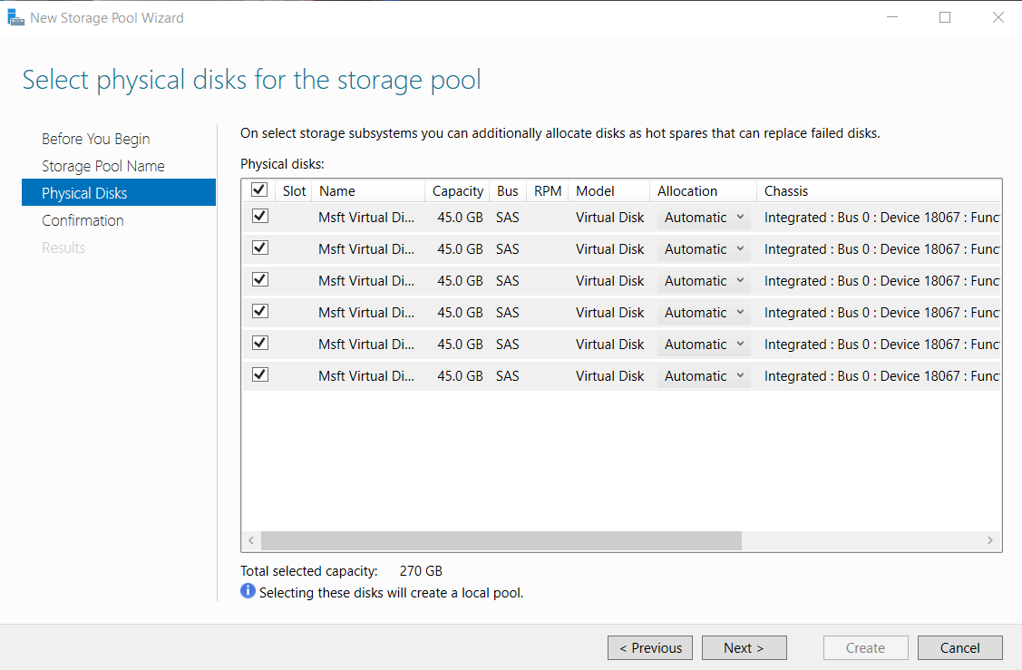

Now go ahead and select create.

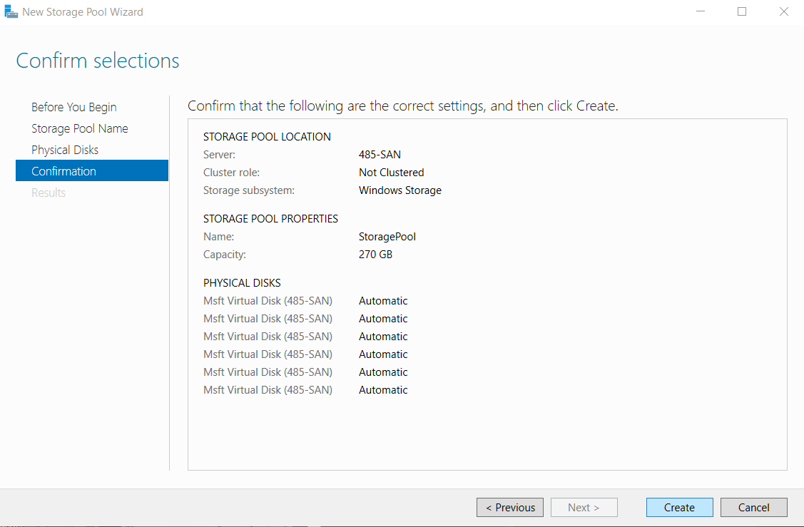

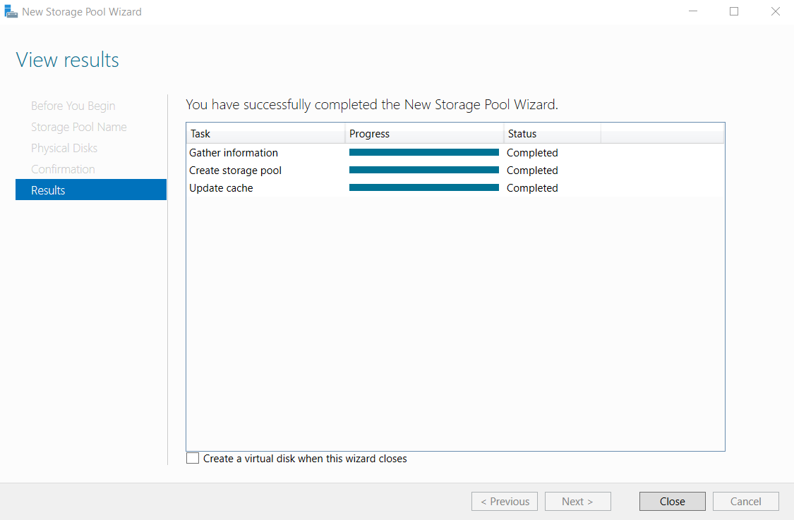

Next, we’re going to create our Virtual Disk in the SAN Powershell to avoid it failing in the GUI.



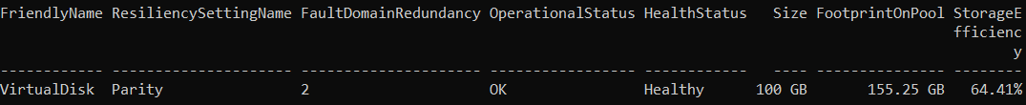

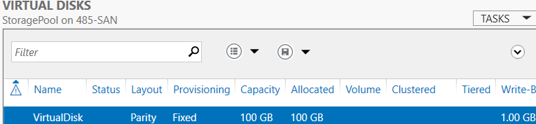

We’re now going to create a Quorum disk in the SAN Powershell.

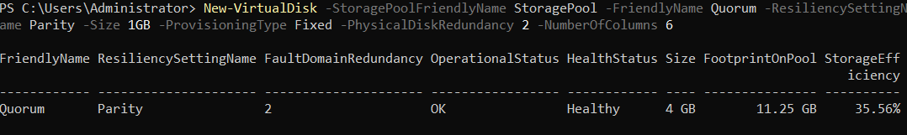

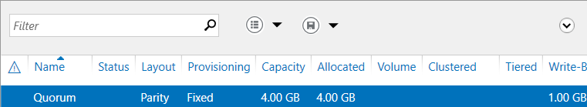

# **Creating & Configuring HV1 & HV2**

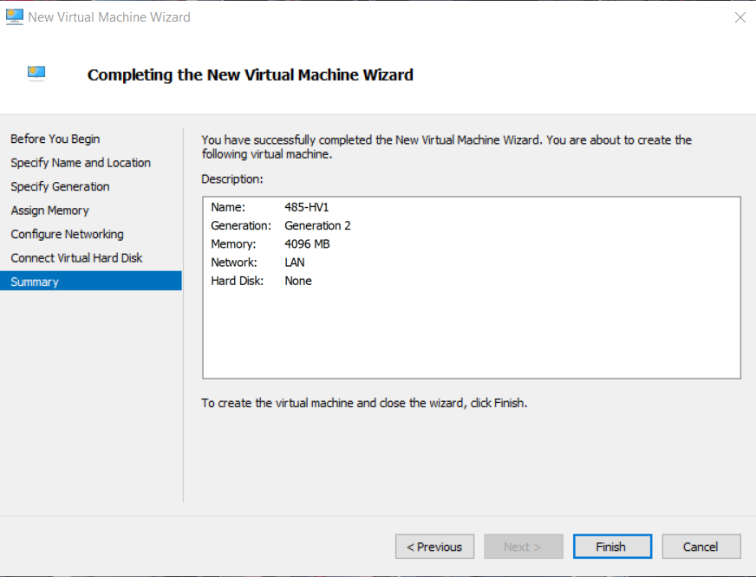

Next, we’re going to add processors.



Now you will add 3 more Network Adapters.

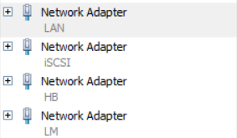

Now we’re going to use our differencing disk.

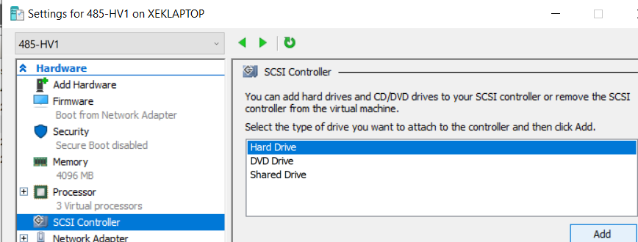

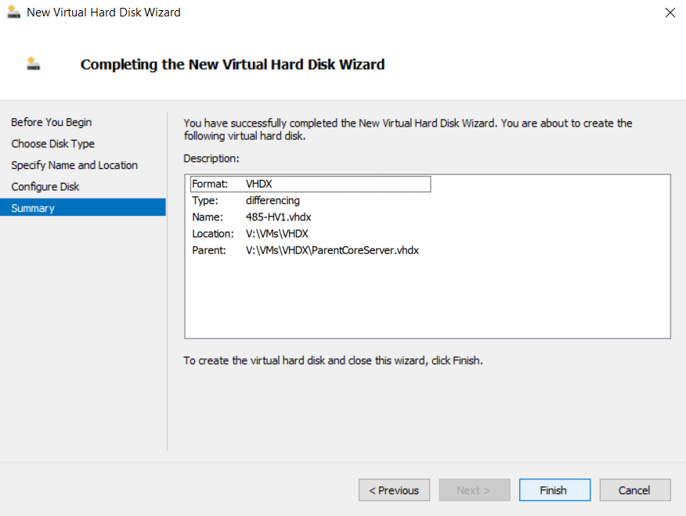

Do the exact same as you did for HV1 for HV2.

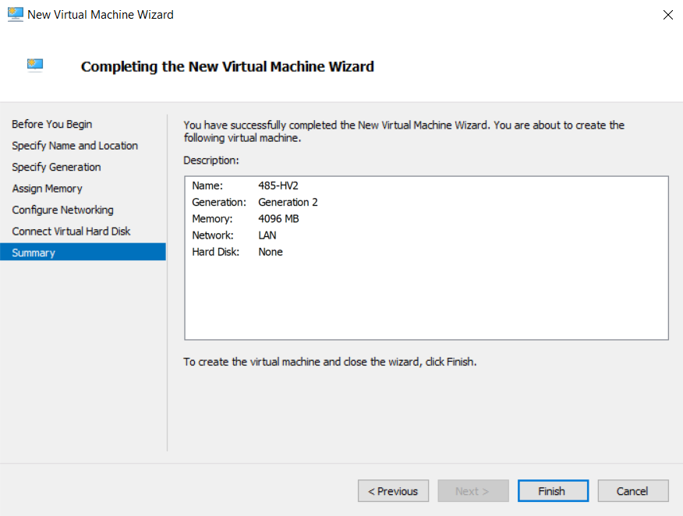





Now we’re going to use our differencing disk.



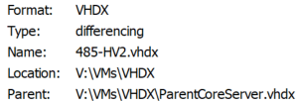

We’re now going to configure HV1.

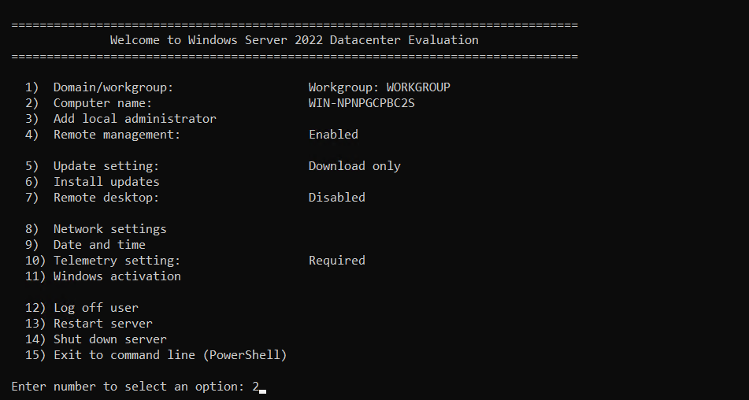

We’re going to change the name of our device.

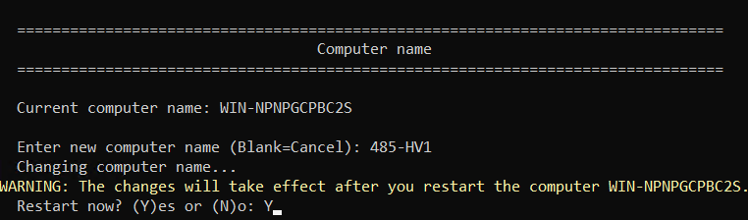

Next, we’re going to rename our Network Adapters.

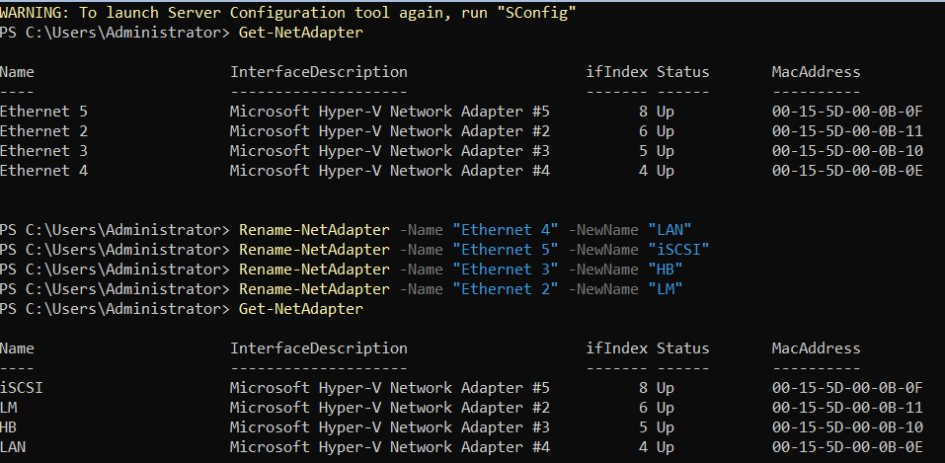

Now we’re going to statically assign IP Addresses for each individual Network Adapter.

(LAN)

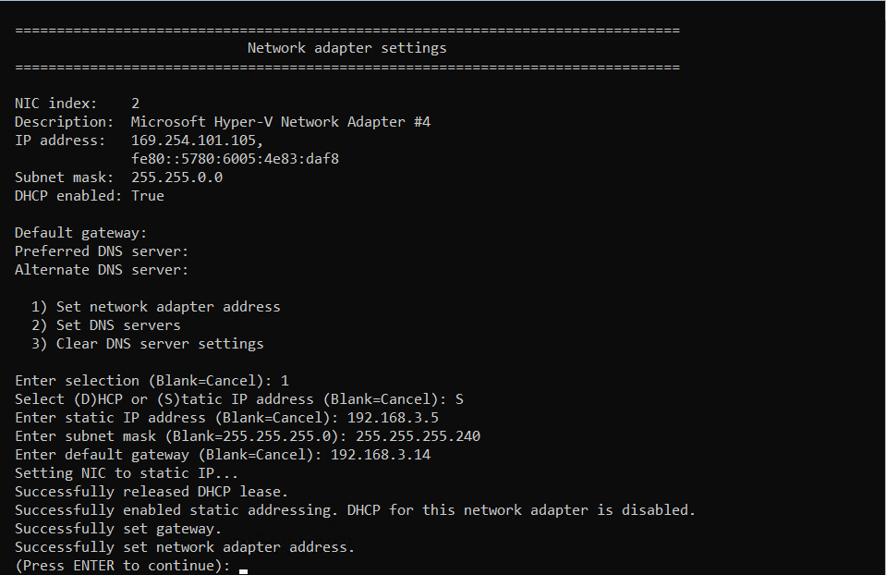

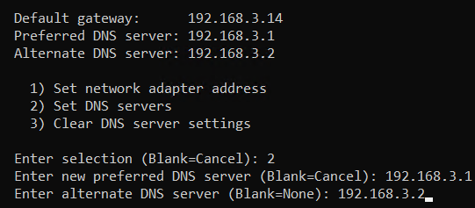

(iSCSI)

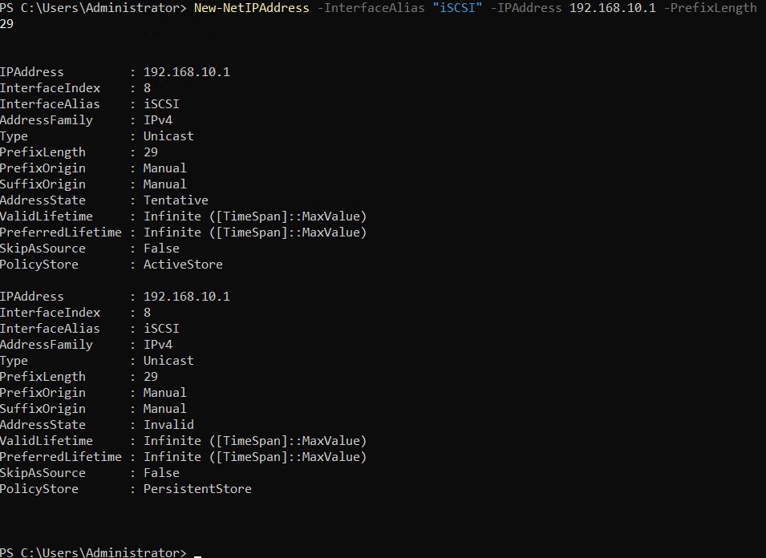

(HB)

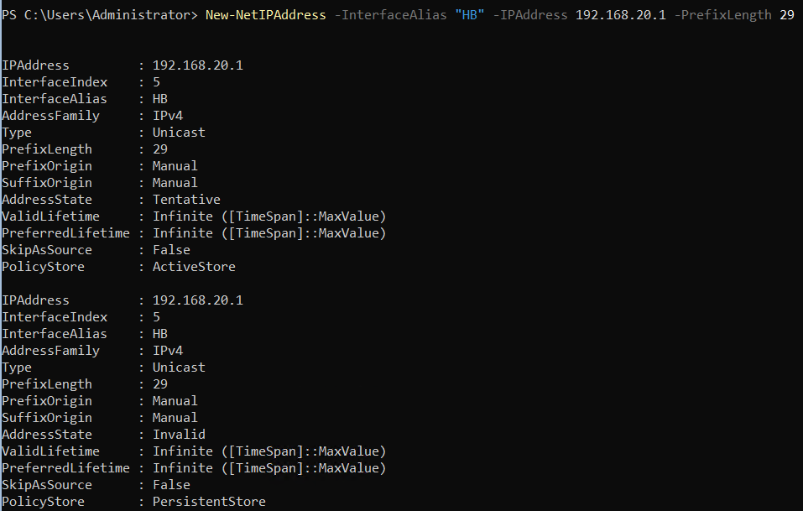

(LM)

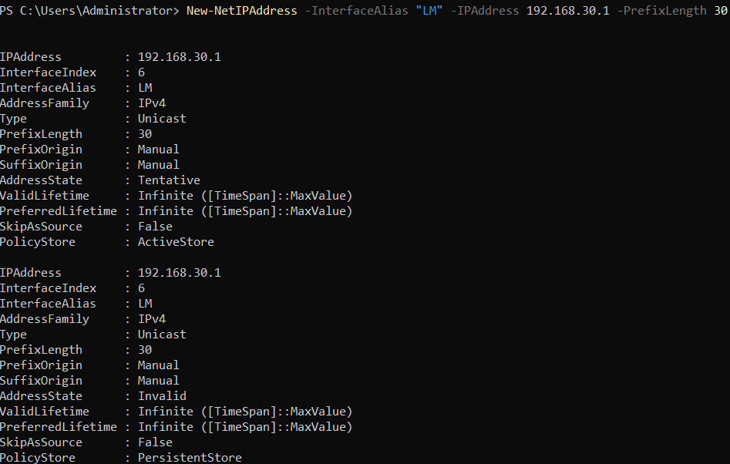

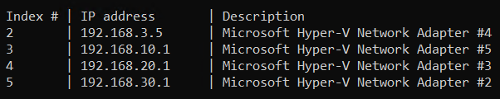

Next, we’re going to disable the firewall.



We’re going to allow this server to be pinged.

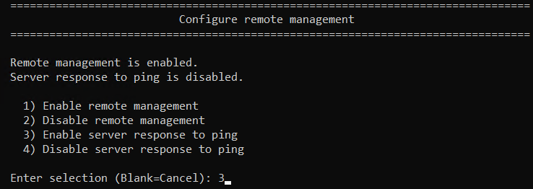

To ensure that HV1 can do virtualization within itself this command needs to be done.



Now we’re going to domain join HV1.













We’re now going to configure HV2



We’re going to change the name of our device.

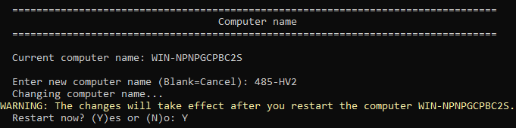

Next, we’re going to rename our Network Adapters.

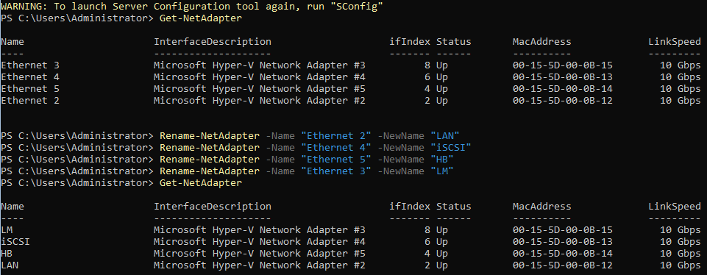

Now we’re going to statically assign IP Addresses for each individual Network Adapter.

(LAN)

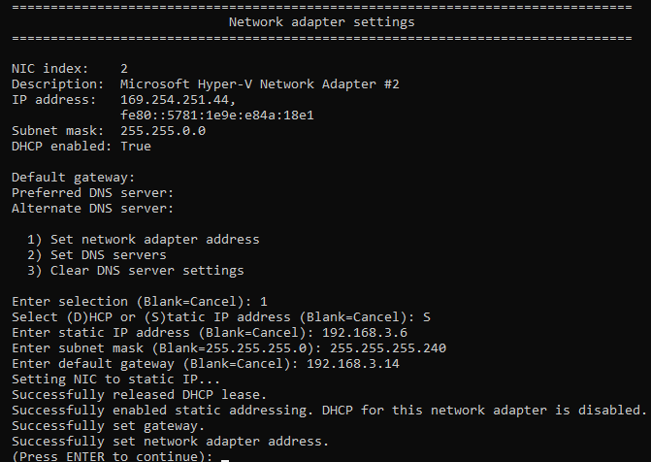

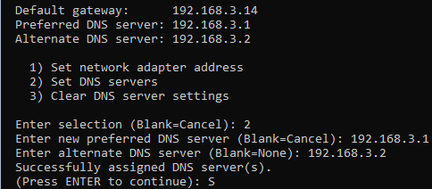

(iSCSI)

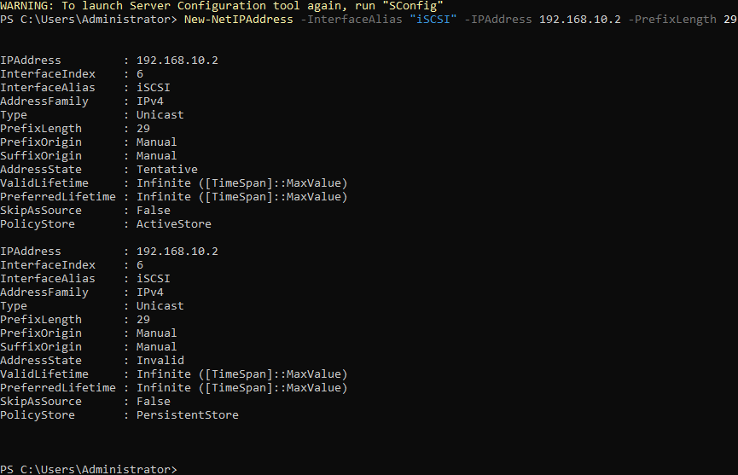

(HB)

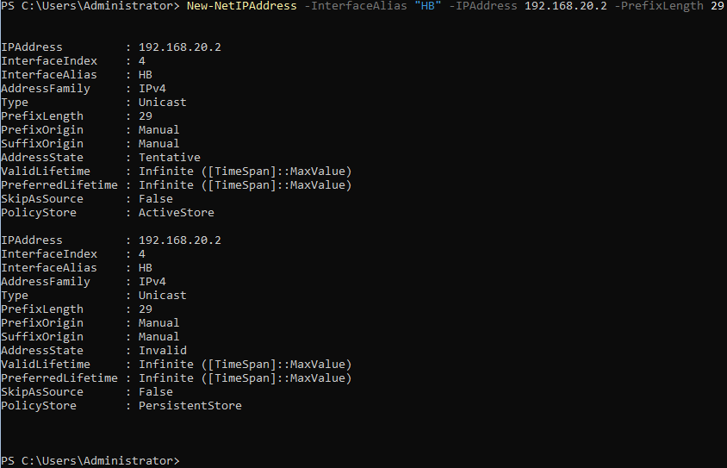

(LM)

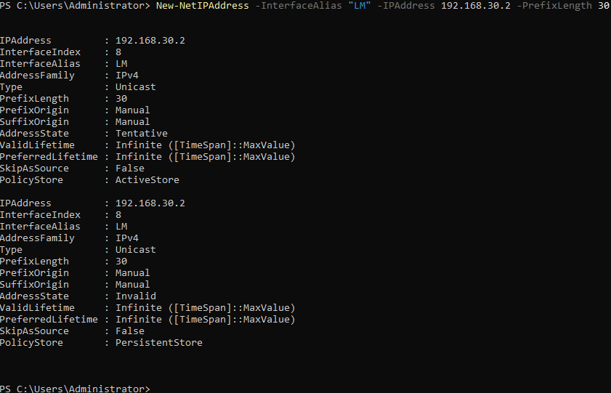

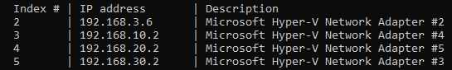

Next, we’re going to disable the firewall.



We’re going to allow this server to be pinged.



To ensure that HV2 can do virtualization within itself this command needs to be done.



Now we’re going to domain join HV2.













Now we’re going to join HV1 & HV2 to our host’s Server Manager.

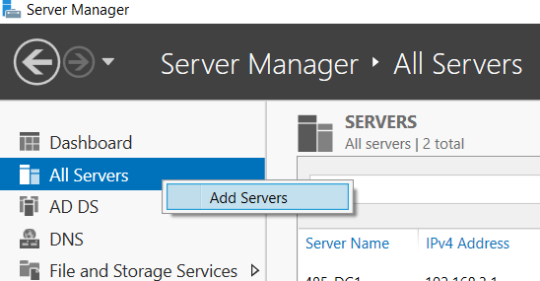

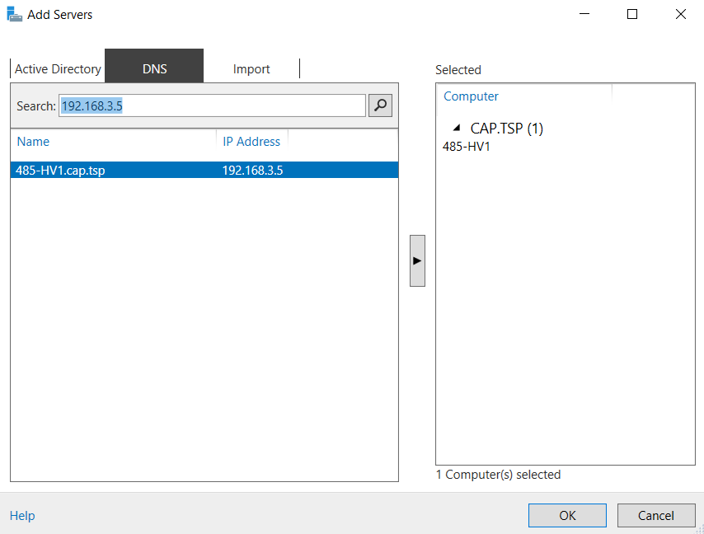

Now we’re going to right click them and select “Manage As” to resolve the Kerberos authentication error.

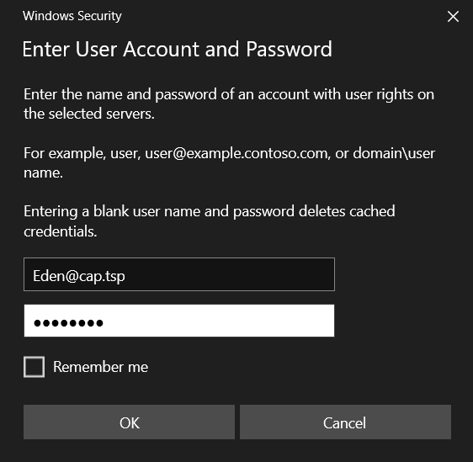

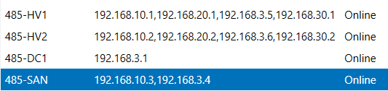

# **Failover Cluster Configuration**

Now we’re going to install Hyper-V in Powershell on HV1 & HV2.



Now we’re going to install a Failover-Cluster role on HV1 & HV2.



Now head to your SAN and install the following feature.



Now we are going to format, initialize & partition the Virtual Disk.

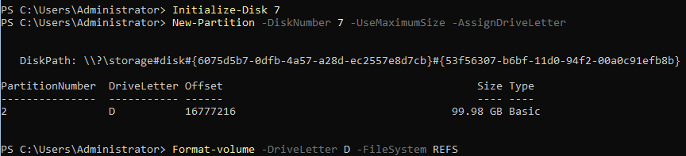

We’re now going to format our iSCSI Virtual Disk.



Now you will do the same except for the Quorum/Witness.

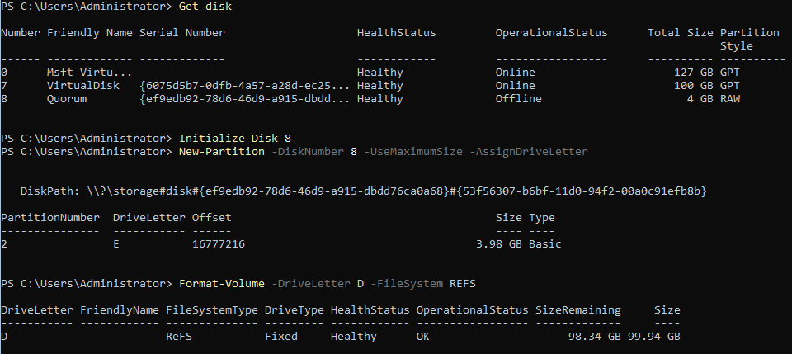

I accidentally formatted by “D:” drive which was my VirtualDisk so now I am going to recreate my VirtualDisk & my Quroum.

(What I should have written)



Now I’m going to recreate my VirtualDisk.



Now we’re going to create the Quorum.



We’re now going to set our target on the Virtual Disk we created earlier.



(Write down for later) iqn.1991-05.com.microsoft:485-san-virtualdisk-target

We’re now going to set our target as the Quorum we created earlier.



(Write down for later) iqn.1991-05.com.microsoft:485-san-quorum-target

We’re now going to map the Virtual Disk.



We’re now going to map the Quorum.



Now we’re going to head to HV1 & HV2 and enter the following commands:



Head to HV2 and enter the following:

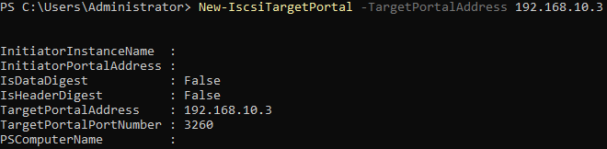

We’re now going to connect our iSCSI Target

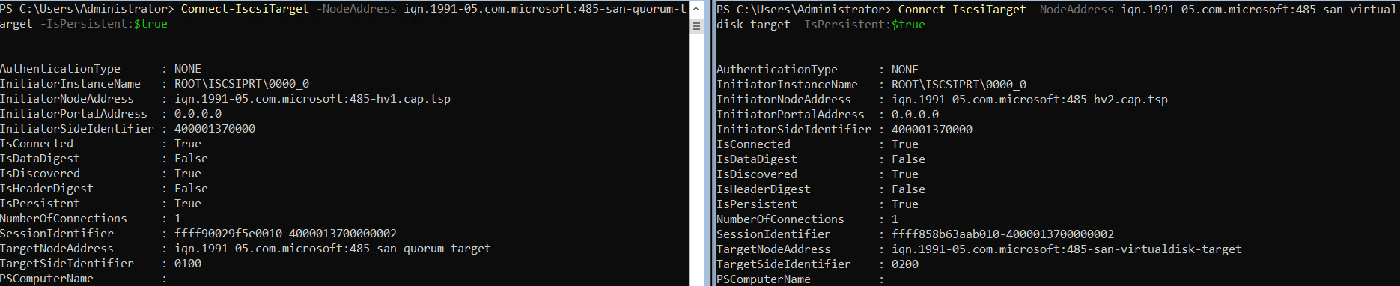

We’re now going to install the Cluster.





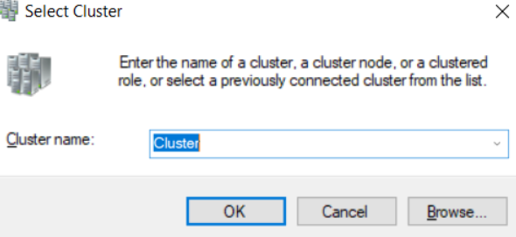

(New Name is “485-HVCluster”

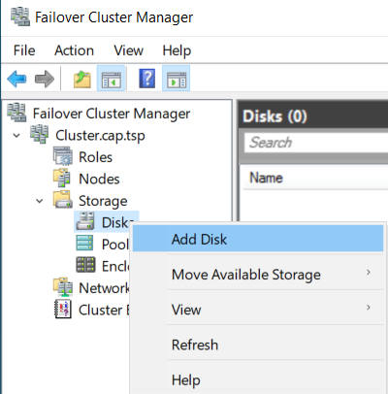

Now we’re going to bring our Virtual Disk & Quorum online.

(Virtual Disk)

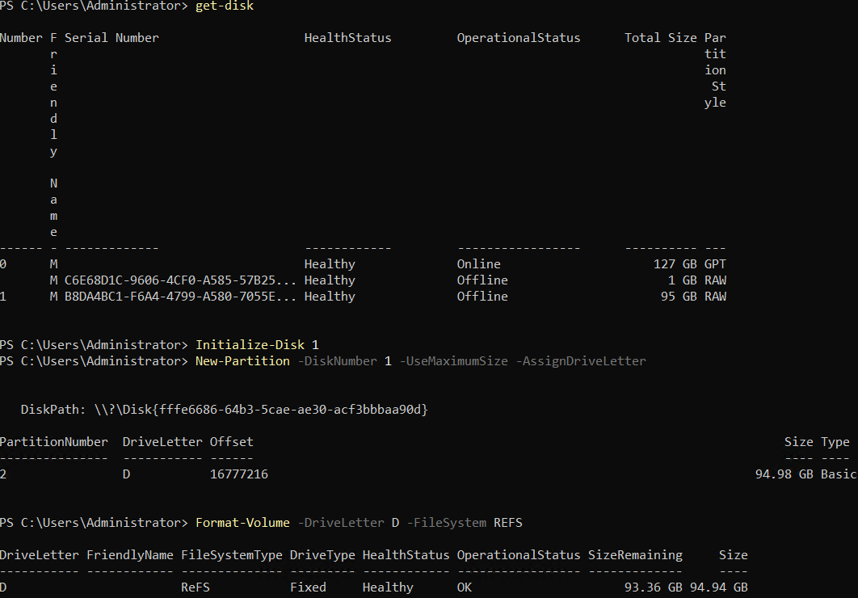

(Quorum)

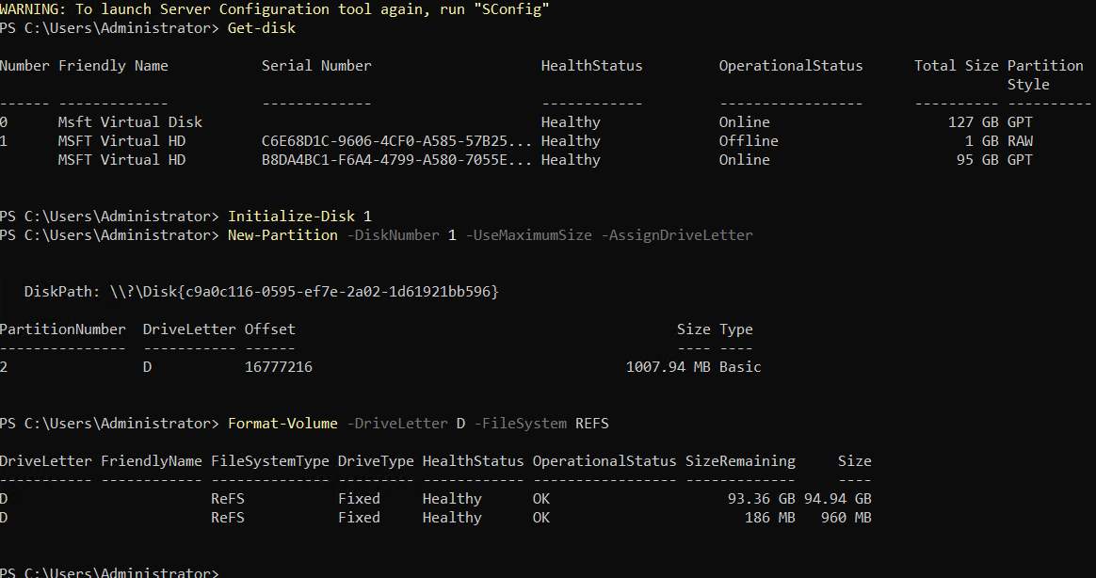

We’re now going to open Failover Cluster Manager & connect to the cluster we created earlier.

After that head down to

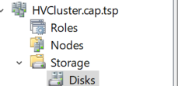

Select “Add Disk” and select the 2 disks you created.



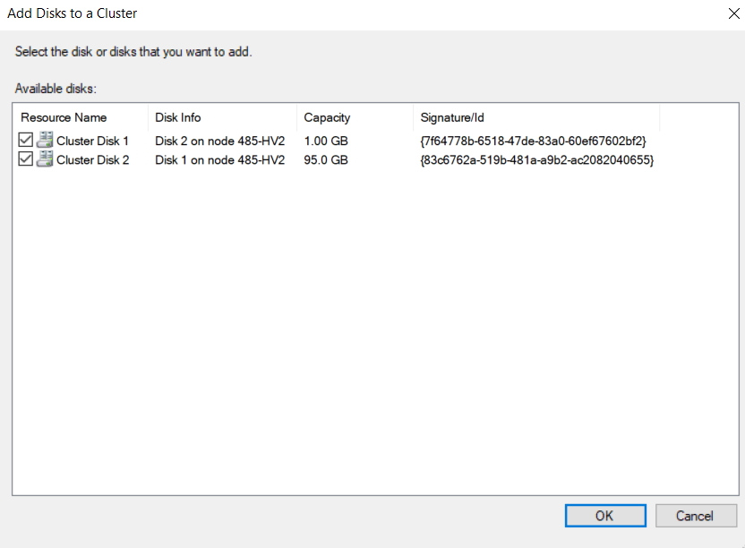

We’re now going to select “Add to Cluster Shared Volumes” on our Virtual Disk.



After you’ve selected “Add to Cluster Shared Volumes”

Navigate to file explorer and search the following:



Inside of “Volume1” create the following:

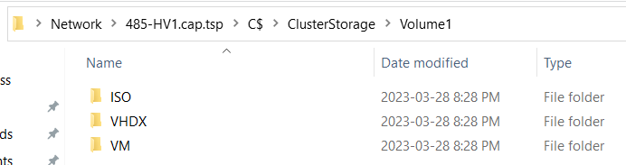

Now we’re going to locate our ISO and place it in the ISO folder.

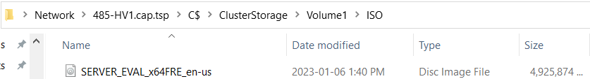

We’re now going to assign our Quorum disk as the witness.

Right click “HVCluster>More Actions>Configure Cluster Quorum Settings”

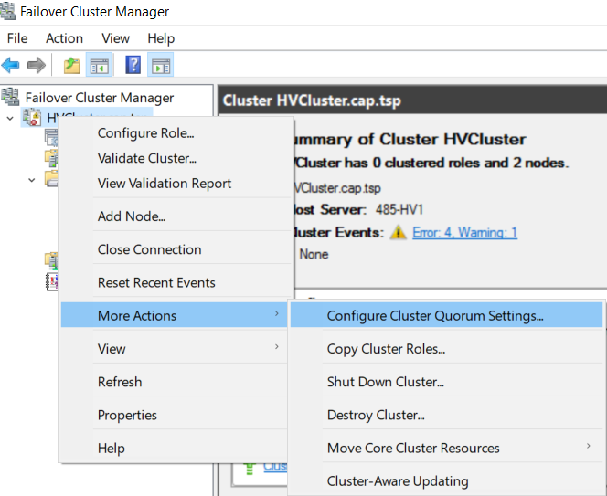

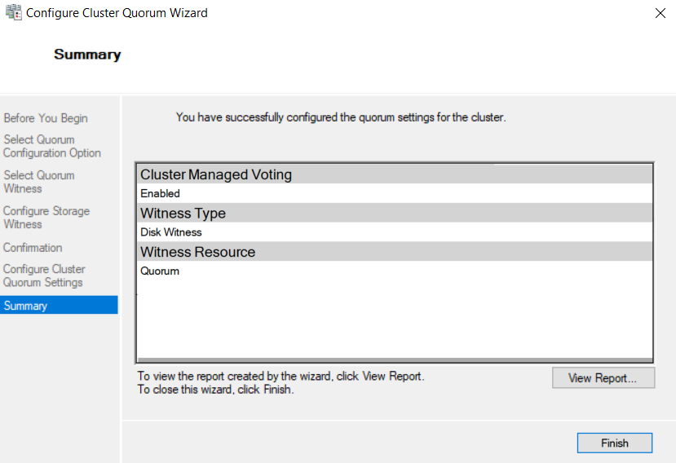



# **Live Migration**

Now we’re going to head to.





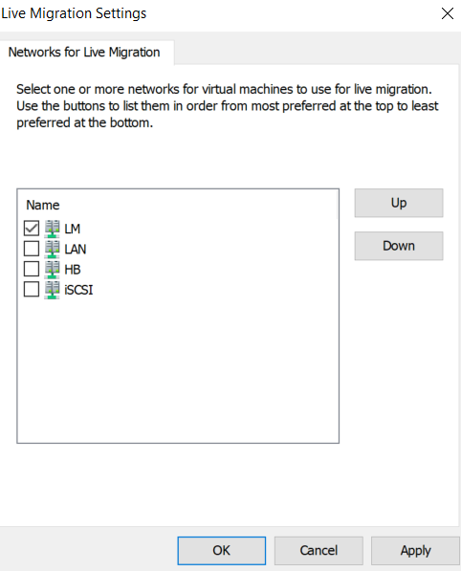

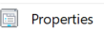

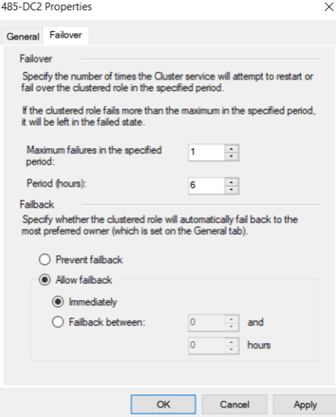

We’re now going to create our switches for (485-HV2).

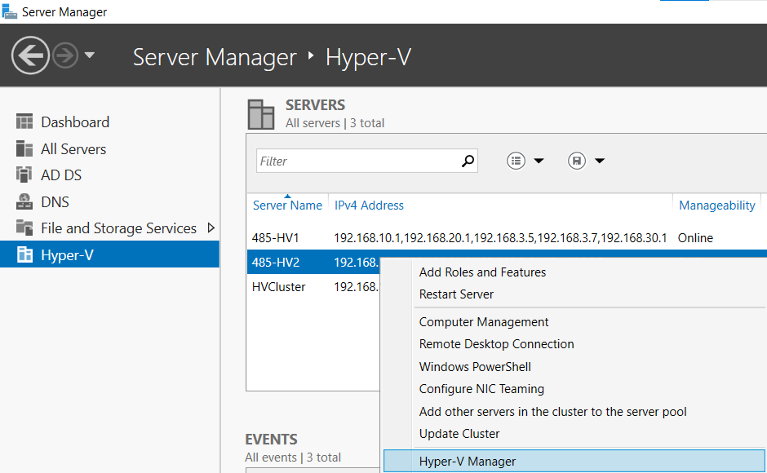



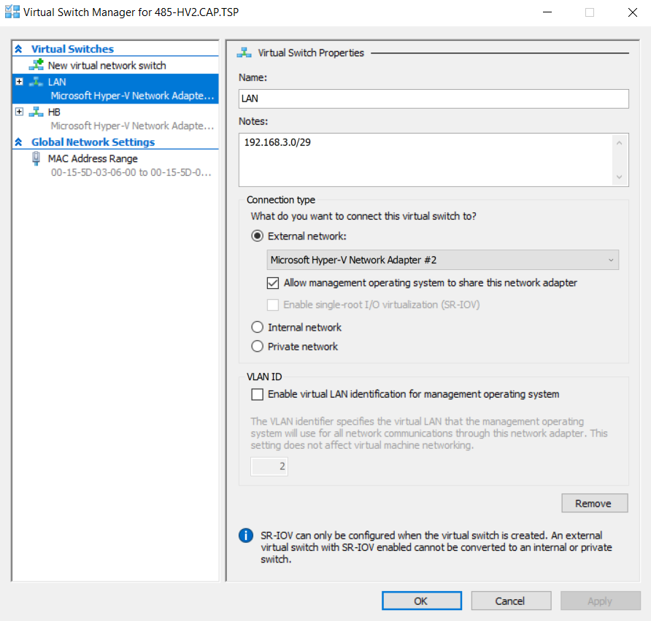

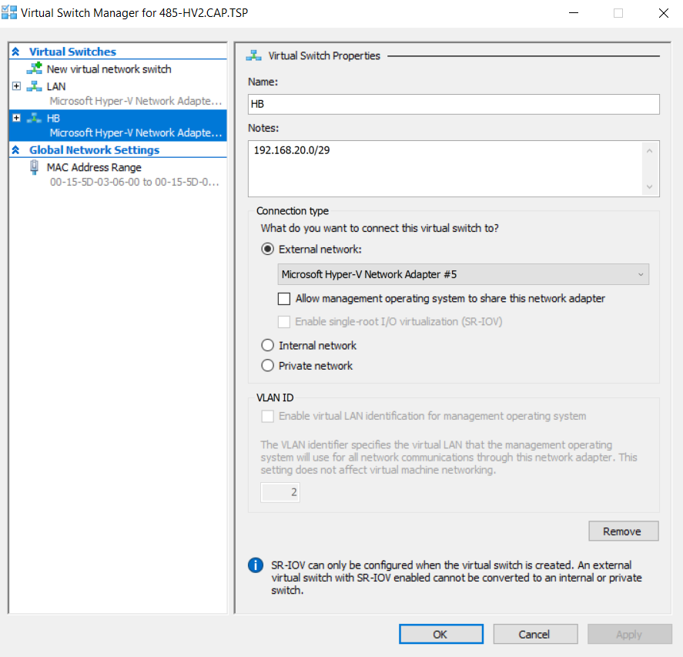

We’re now going to create our switches for (485-HV1).

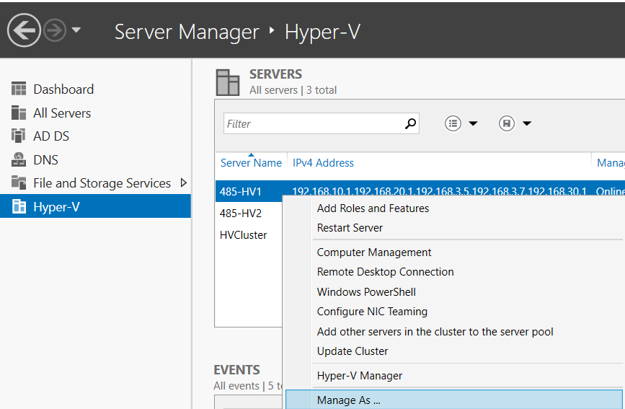



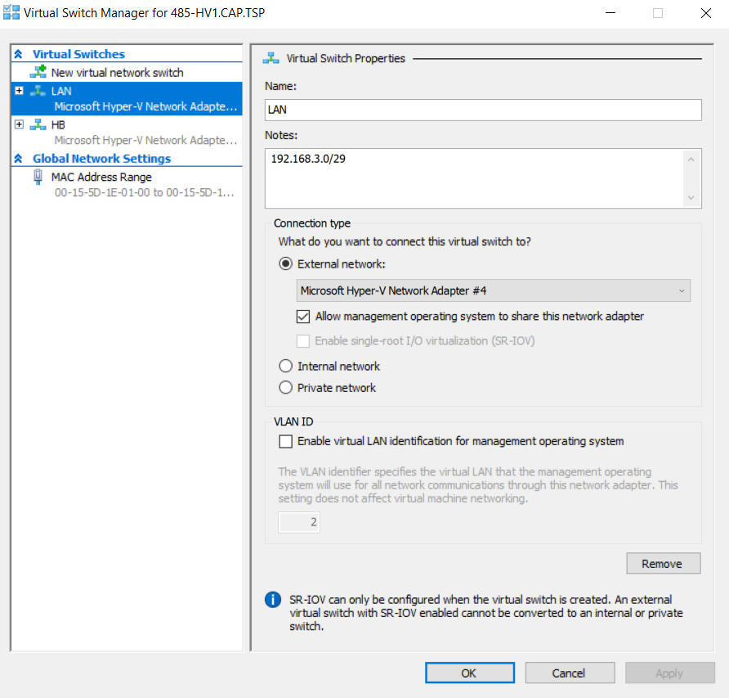

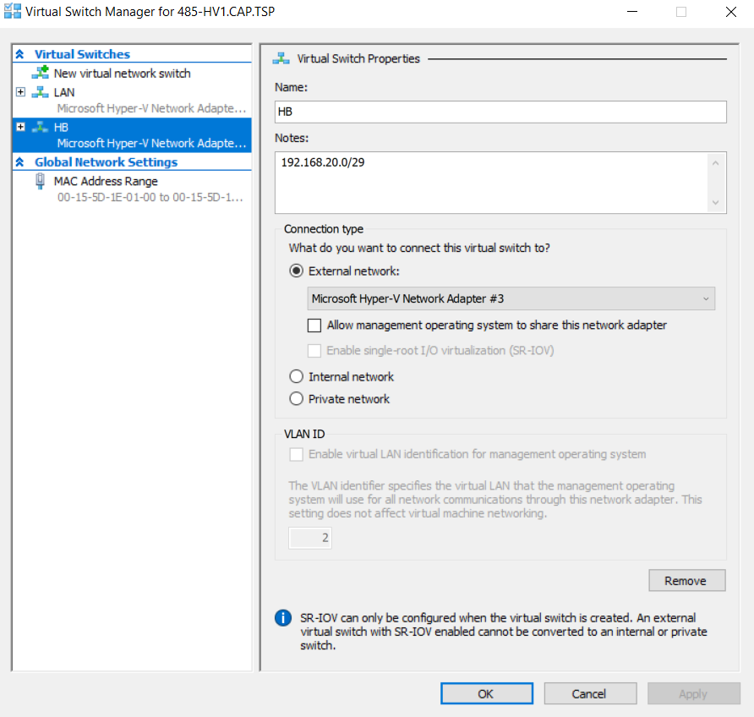

# **Creating & Configuring DC2**

We’re now going to create our DC2 inside of (485-HV1)

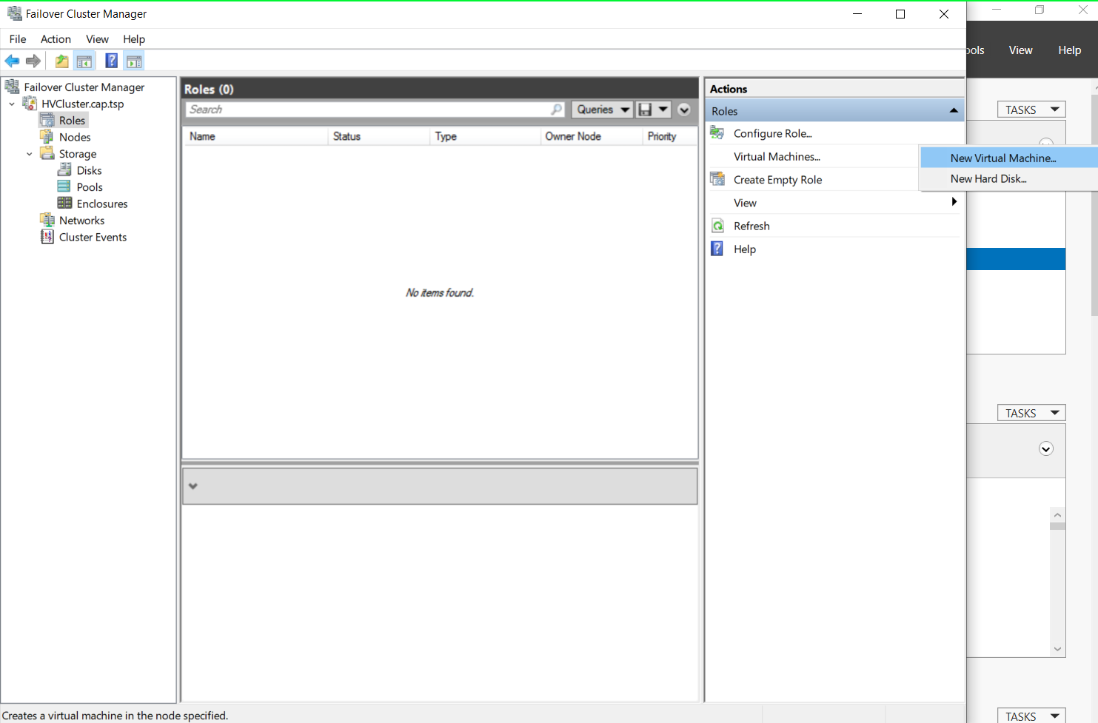

Make sure you change the location to the following:

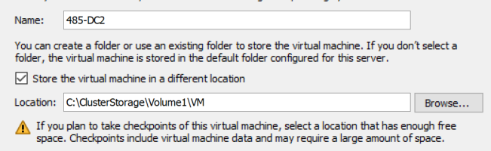

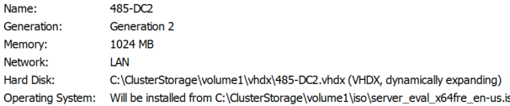

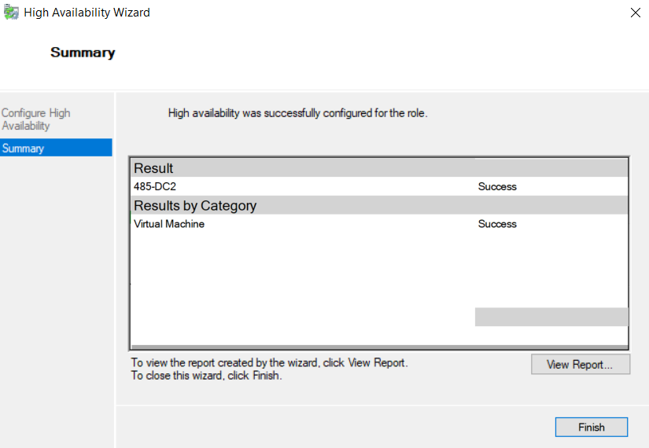

Head to “Advanced Features” and enable “Mac Address Spoofing” on HV1/HV2.

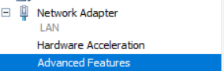

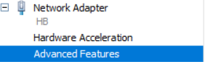



Now create your “ADdb” drive for your “485-DC2”

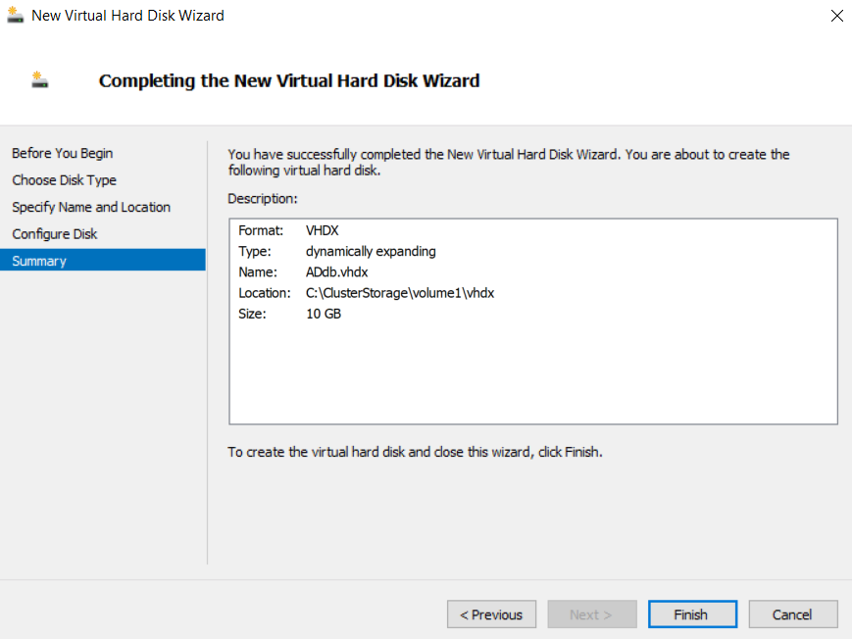

We’re now going to do post installation setup on our “485-DC2”

First, we’re going to change the device’s name.

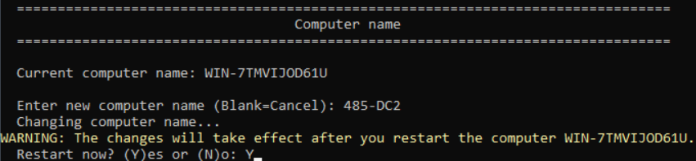

We’re now going to rename our local user.



Now we will set the IP settings.

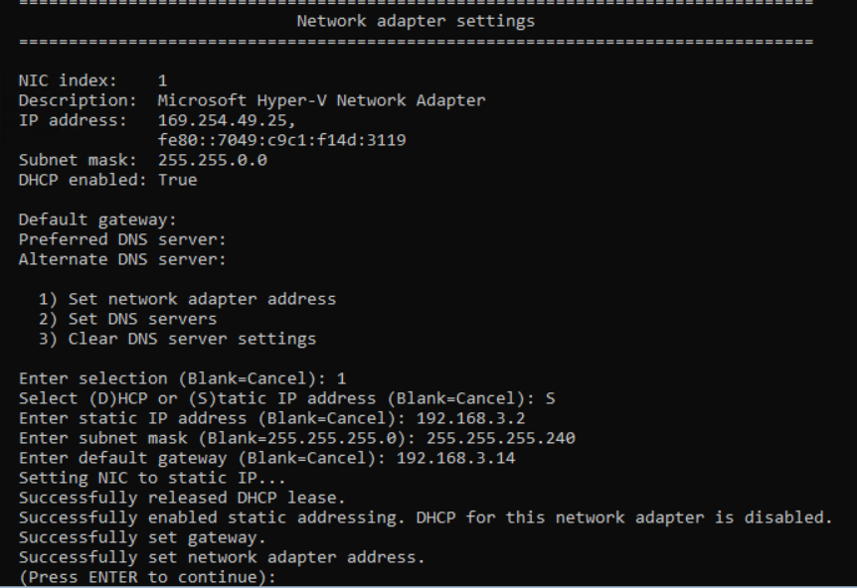

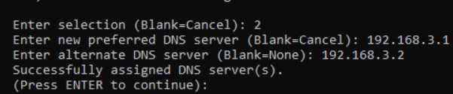

Now we’re going to rename our network adapter.

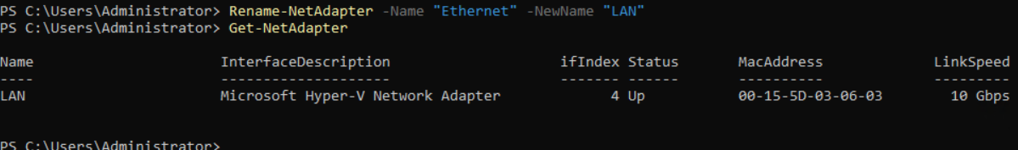

After joining the domain, initialize and format the database drive.

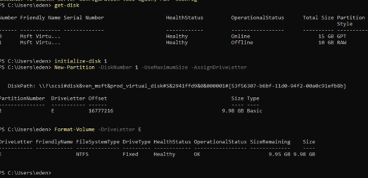

Now we will create the file paths.

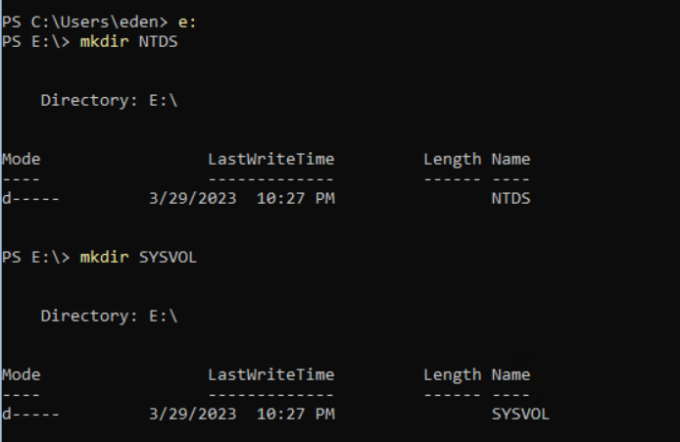

We are now going to Install ADDS.



Promote DC2 to a Domain Controller.

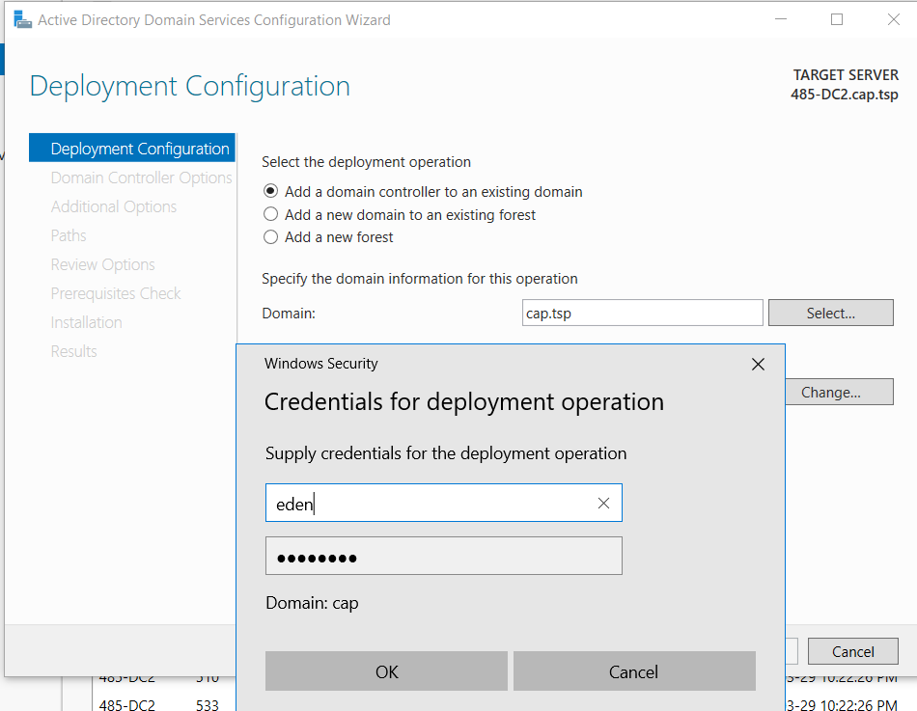

Do not update DNS Delegation

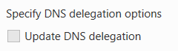

Replicate from DC1

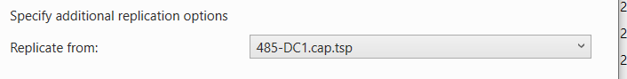

Change paths to database drive.

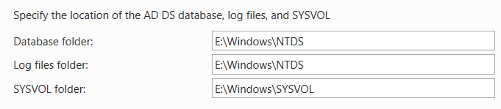

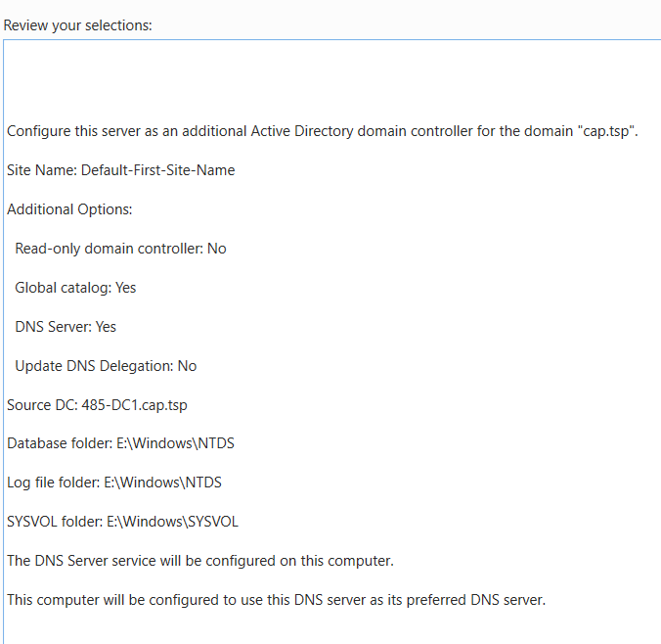

We are now going to browse in ADUC for both DC’s to make sure that they replicate.

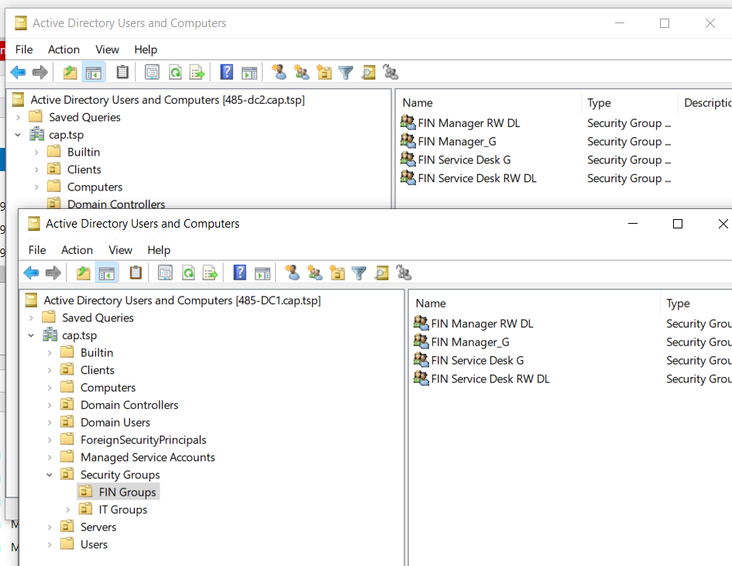

# **Creating & Configuring FS1**

We’re now going to create our FS1 inside of (485-HV1)

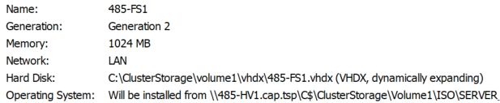

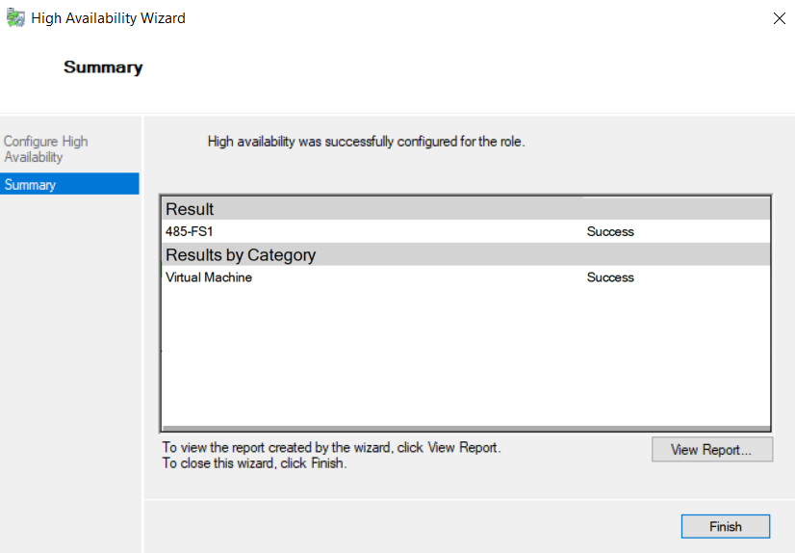

Now you’re going to add your HB network adapter, FS1 should have an external LAN & HB.

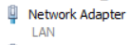

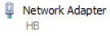

You would then do post installation setup, domain join, then you would install roles & features.

# **Creating & Configuring FS2**

We’re now going to create our FS2 inside of (485-HV2)

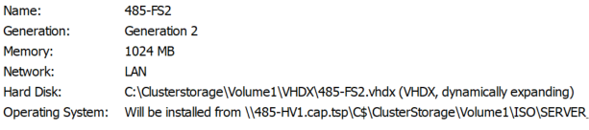

(VHD Set)

Didn’t create one, never finished FS2.

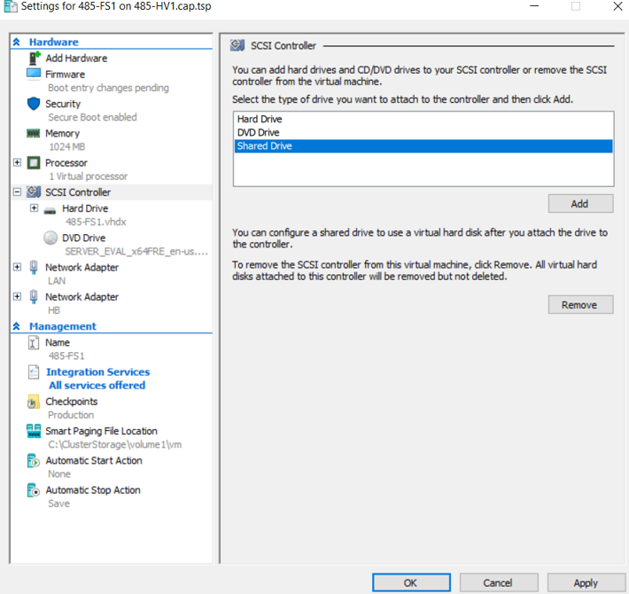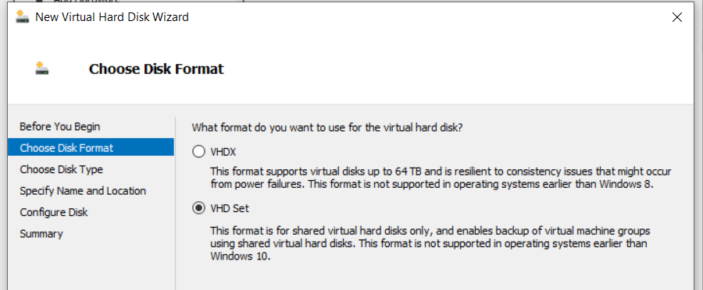

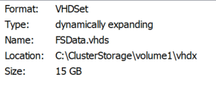

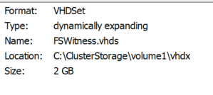

# **Making Mapped Drive & Folder Redirection**

(Mapped drives and Folder redirection are done after the File servers, which I never finished.)

(Sorry for the screenshot quality, I took a video and went back for screenshots)

First, you’re going to head to “Group Policy Management”.



Head to the “Group Policy Objects” in “cap.tsp”.

Create a policy named “Mapped Drive”.

We’re now going to edit it.

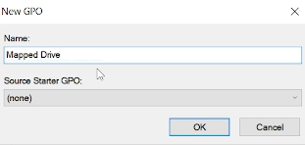

Head to “Drive Maps”.

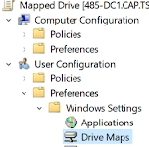

Select new and select “Mapped Drive”

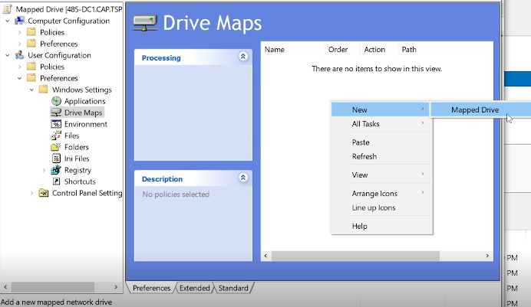

Enter the following and hit apply and ok.

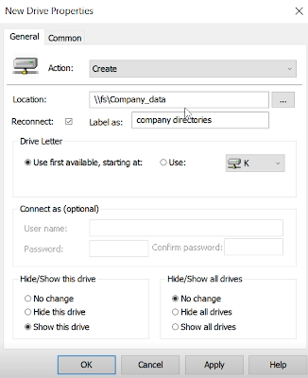



Now you will head to “Domain Users”.

And link the existing GPO you created.

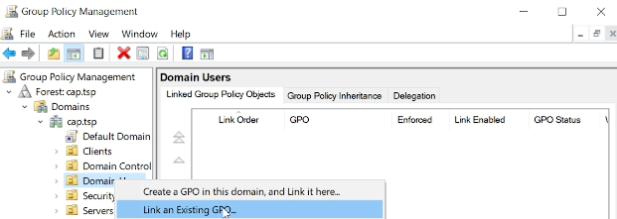



Now create a new GPO called “Folder Redirection”.

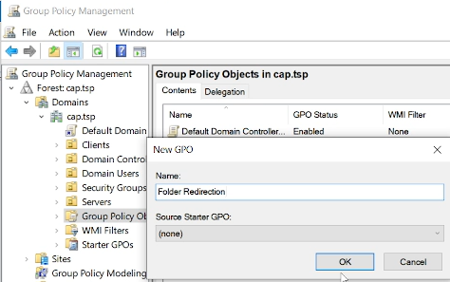

Now edit that GPO, head to User Configuration > Policies > Windows Settings > Folder Redirection > Desktop.

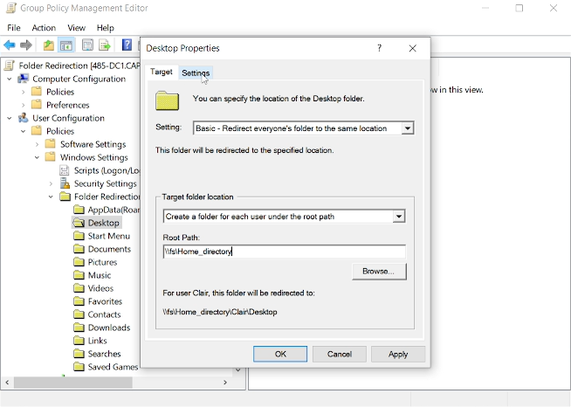

Head to settings and switch the policy removal then hit apply.

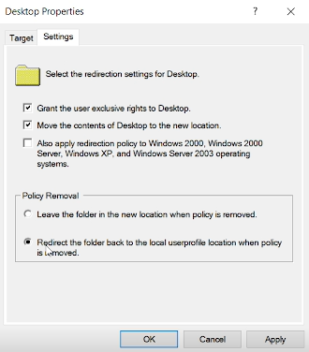

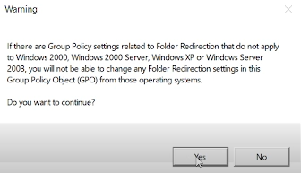

Now you will head to “Documents” & “Properties”.

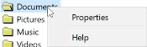

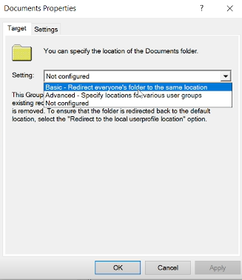

Now set your “Root Path” to the following:

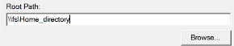

Head over to “Settings”

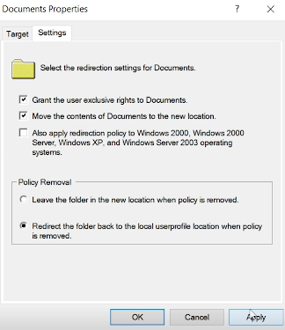

Select apply & ok.

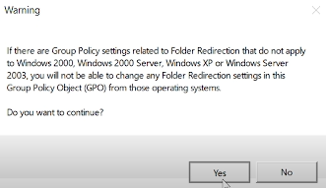

Select yes.

Head back to “Domain Users”

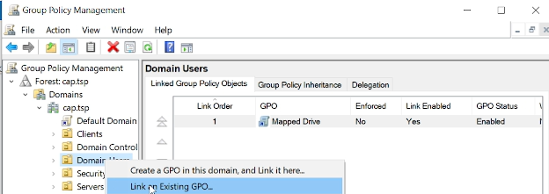

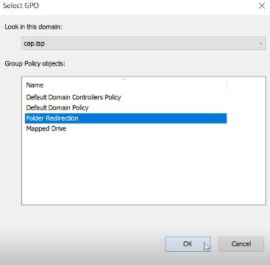

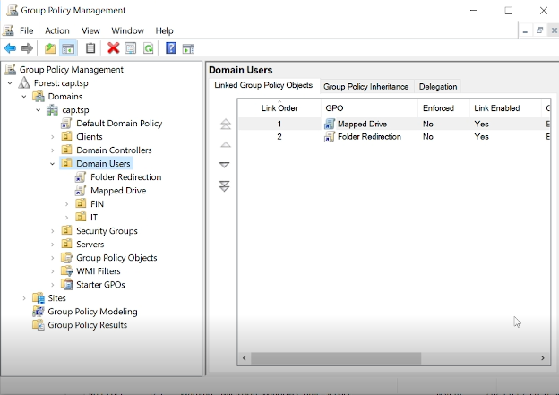

# 

# **Reflective Writing**

I’m not sure where to start, this project was a rollercoaster. A bunch of the information I learned prior, quickly came back as I was doing it again, this type of repetition really helped me learn. I’d be lying to you if I said this was an easy project. Regardless of the difficulty I found it to be extremely interesting and a great challenge. Whether it be the Firewall, Group Policies, Share Files, SAN, File Servers. I’d say the most interesting part for me personally was Clustering the Hypervisors, despite having a million issues to overcome. Prior to this program I thought I knew a bunch of IT terms and technologies, but I was quickly humbled.

Although I encountered many issues during this project such as corrupting most of my environment. There was one specific issue I never found a permanent fix for. HV1/HV2 and HVCluster kept getting “Online – Data retrieval failures occurred”, I must have spent at least 12 hours trying to fix this. I restarted the msiSCSI service, restarted HV1/HV2, I made sure the targets were connected, made sure the portal was correct, made sure I had set the correct initiators. I tried deleting the Cluster & recreating it, making sure to delete the A record and removing the Cluster from ADUC. But shortly after thinking I had fixed it with my new Cluster, I refreshed Server Manager and got disappointed to see “Data retrieval failures occurred”. After that happening I was led to believe that it could have been corruption of HV1/HV2, but throughout this all. The cluster seemed to work perfectly fine, so I pushed through due to a lack of time.

Many of the guides I used throughout this Capstone project were previously documented from past assignments, thankfully they were good enough to lead me in the right direction. Looking back, I wish I spent more effort on my documentation having known so much we had learned in the past would be used in our final project. Towards the beginning of the project, I tried to put extra effort into my Capstone’s documentation. I tried to manage my time wisely by setting at least 8 hours a day to spend progressing through the project & working on my documentation. Life quickly took its toll and I found myself not spending as much time as I would have liked working on the project. Regardless of my time management, there were many times where I felt like I couldn’t do this, or I didn’t understand. But I persevered and tried my best to keep a positive attitude, which resulted in me handing in this project, despite not meeting all the deliverables.

I wouldn’t have got as far as I did without the help of the troubleshooting channel and many individuals in this program. I tried my best to ask questions, to understand concepts rather than just doing them. I let myself be vulnerable, by asking questions and asking for help. This program took me out of my comfort zone, and I wouldn’t change a thing. I want to end this off by saying a huge thanks to you Rajen, and Orrett as well. You guys exceeded my expectations of professors. Because of this program, I am ready to step foot into the IT world, I feel extremely ready to work and continue to learn.